

Trade & Order Management Systems

Version 1


Cognizant Technology Solutions US Corporation
500, Glenpointe Center West
Teaneck, NJ 07666

www.cognizant.com

Table of Contents
1. Introduction 5
1.1. Overview 5
1.2. Scope 6
1.3. Audience 6
2. Trading Process Overview 6
2.1. Key Entities 6
2.2. Life cycle of Trade 7
2.2.1. Order placement and Execution 7
2.2.2. Trade Allocation 8
2.2.3. Trade Confirmation 8
2.2.4. Trade Notification to Custodian & Reconciliation 8
2.2.5. Trade Settlement 8
3. Buy-Side Order Management System 10
3.1. What is a OMS 10
3.2. Core Features of OMS 11
3.2.1. OMS Trade Compliance 11
3.2.1.1. Pre-trade compliance 11
3.2.1.2. Post-trade compliance 12
3.2.1.3. Sample compliance rules 12
3.2.2. Order Management 13
3.2.2.1. Order Creation 14
3.2.2.2. Order Routing 18
3.2.2.3. Post-Trade Processing 19
3.3. Supporting Features of OMS 23
3.3.1. Portfolio Management 23
3.3.1.1. Portfolio Modeling 23
3.3.1.2. Portfolio Monitoring 23
3.3.1.3. Cash Management 24
3.3.1.4. Performance Measurement 24
3.3.1.5. Performance Attribution 24
3.3.1.6. Order Generation 25
3.3.1.7. Order Cancellation / Modification 25
3.3.1.8. PM-Level Order Strategy/Management 25
3.3.2. Interface Requirements 26
3.3.2.1. Interfaces to the Order Management System 26
3.3.2.2. Interface Mechanisms 28
3.3.2.3. Data Exchange in the Ecosystem 28
3.3.3. Query and Reporting 30
3.4. Order State Management System 31
3.5. Reference Data Management 36
3.5.1. Information Captured 37
3.5.2. Customer Account Setup & Security Details Maintenance 38
3.5.3. Identity & Access 39
3.5.4. Instrument/Market Data Setup & Maintenance 39
3.5.5. Miscellaneous Reference Data 39
3.6. Users of OMS 40
4. Sell-Side Order Management System 41
4.1. Order And Execution Management 42
4.1.1. Types of Exchanges: Order / Quote driven 42
4.1.2. Smart Order routing 43
4.1.3. Direct Market Access (DMA) 44
4.1.4. Algorithmic trading 44
4.1.5. Quote management 44
4.2. Trade Management 44
4.2.1. Trade Execution Processing 44
4.2.2. Types of Trade Report 45
4.2.3. Trade Booking 45
4.2.4. Trade Enrichment 45
4.2.5. Trade Allocation 46
4.3. Position Management 46
4.3.1. Position Management 46
4.3.2. Commission Management 48
4.3.3. Profit & Loss calculation 50
5. Technology and Market Trends in OMS 52
5.1. SOA 52
5.2. STP on the Buy-side 54
5.3. FIX Protocol 57
5.4. Execution Management Systems 59
5.5. Direct Market Access 60
5.6. Convergence of OMS, EMS and DMA 61
5.7. Regulation NMS, MiFID and their Impact on OMS 64
5.8. Best Execution 66
6. Major Vendors 71
6.1. Charles River IMS 71
6.2. Eze Castle Software 72
6.3. Sungard Brass 73
6.4. Macgregor XIP 73
6.5. Moxy 74
6.6. Fidessa LatentZero 74
6.7. Long View 76
7. Vendor Selection 77
8. References 79
9. Annexure 80
9.1. Comparison of Vendors 80

List of Figures

Figure 1: Entities in a Trade Life Cycle 6
Figure 2: Trade life cycle with Order Management Systems 10
Figure 3: Components of the Order Management Module 14
Figure 4: Order Management Ecosystem 26
Figure 5: Order Tracking without Order State Management 31
Figure 6: Order Tracking with Order State Management 32
Figure 7: Order State Management System 33
Figure 8: Reference Data in Transaction Life Cycle 37
Figure 9: N-Tier vs SOA Architechture 52
Figure 10: Reference SOA Architecture 53
Figure 11: Historical OMS EMS DMS Overlap 63
Figure 12: Areas of Convergence and Innovation 64

- Introduction
  - Overview
A trading cycle begins with an investment opportunity and ends with a settlement resulting in a change in client’s portfolio position. The key to optimizing this end to end trade process is to automate and integrate as many steps and interfaces as possible thereby save time & effort and mitigate operational risks. This requirement is met by the Trade Order Management Systems.

Trade Order Management Systems have become nerve center of any trading activity. Order Management Systems (OMS) integrate the operations of front, middle and back offices. They perform order management and compliance in the front office; risk management and post-trade support in the middle office; and portfolio management services like position keeping, performance measurement reporting etc in the back office. An OMS comprises of various modules with each one serving a specific purpose in the trade life-cycle.

With the evolution of order management technology and the proliferation of connectivity to electronic markets, the role of the buy-side trader is changing. While buy-side traders have always been involved in the investment process, order management systems have empowered them to have more discretion and control over their orders.

The first versions of OMS could simply connect the buy-side portfolio manager with the buy-side trader. For a long time it served as a medium for automating internal communications - allowing the trader to electronically collect orders and instructions from portfolio managers, aggregate them into blocks, manage executions, collect fills and perform allocations. Most orders were passed off to the sell-side broker with the buy-side having little control of how those orders were executed.

The transformation of the buy side began in the early '90s, when buy- and sell-side firms began adopting the Financial Information Exchange (FIX) protocol - a language that allows traders to route orders through OMSs. The adoption of FIX enabled the buy side to send orders electronically to brokers without having a conversation.

Today the OMS is a key tool in the whole trade life cycle. The order management systems have empowered buy-side traders with greater functionality. Offering a myriad of execution opportunities, OMSs provide access to electronic markets, crossing networks, direct market access platforms and algorithmic trading strategies. Not only do they enable traders to better manage their internal workflow, their robust functionality allows traders to better control their orders by managing how orders are executed. Today's OMSs have emerged as portfolio management systems with functionality that ranges from pre-trade through post-trade support.

  - Scope
- Trading, its components and entities
- Components of Buy-Side Order Management Systems
- Components of Sell-Side Order Management Systems
- Technology and trends in OMS
- Major Vendors providing OMS buy-side products
- Vendor Selection criteria for OMS

  - Audience
- Business Analysts , Domain Consultants & Business Subject Matter Experts (SMEs)
- Project team in the requirements phase for a trade order management system
- Project team in the subsequent phases

- Trading Process Overview
The trading process for the Institutional investors, the buy-side of the market, aims to achieve best price and execution on their orders. They need stock trading systems which give them insight into trading patterns and access to a large pool of brokers. These stock trading systems should be quick and easy to use and allow them to direct orders to multiple brokers in the market from a single platform.

  - Key Entities
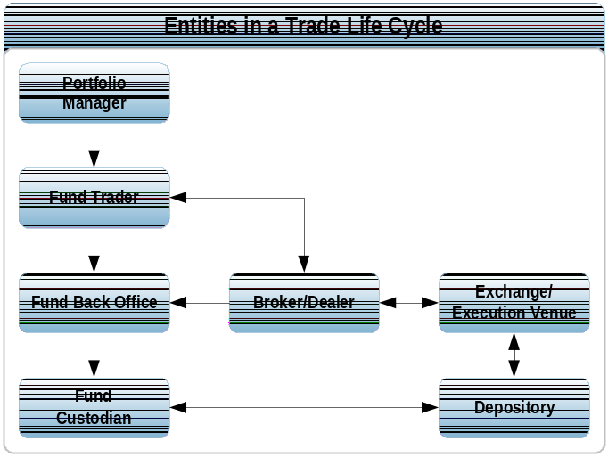
Figure 1: Entities in a Trade Life Cycle

The diagram above depicts a typical life cycle of a trade for an institutional investor. The key entities involved are:

Portfolio Manager/Institutional Investor
Portfolio manager is an individual or a company responsible for investing a fund’s assets, implementing its investment strategy and managing day-to-day portfolio trading.

Fund Trader
The fund trader is part of the buy-side trading desk that receives orders from the portfolio managers and is responsible for getting them executed at the best price either by routing them to a broker or placing orders directly on the exchange/execution venues.

Broker/Dealer
A general term for a securities firm that is engaged in both buying and selling securities for customers (agency trades) and also for his/her own account (principal trades). When acting as a broker, a broker/dealer executes orders on behalf of his/her client. When acting as a dealer, a broker/dealer executes trades for his/her firm's own account. Securities bought for the firm's own account may be sold to clients or other firms, or become a part of the firm's holdings/inventory.

Execution Venues
Execution venues are marketplaces where brokers and dealers meet to buy and sell securities on behalf of investors. Major US execution venues include the New York Stock Exchange (NYSE), the NASDAQ and the American Stock Exchange. In general, execution venues denote the exchanges where orders get matched between counterparties. It could also be other entities such as Electronic Communication Networks (ECNs), ATSs, MTFs, Dealer Networks and Over the Counter (OTC) trading.

Custodian
A custodian is an organization that holds securities and cash on its clients’ behalf. A custodian may provide following services
- Keeping the securities safe i.e. hold the securities in client’s Demat account on their behalf
- Providing daily statements of securities and cash holdings
- Providing current market valuations of securities holdings
- Providing securities lending or borrowing facilities

Back-office
The back office takes care of all the administrative activities of the firm like booking a trade, calculating commissions, corporate actions, generating settlement instructions etc.

Depository
A Depository is a central securities depository through which members affect security deliveries among each other via computerized bookkeeping entries, thereby reducing the physical movement of stock certificates.

  - Life cycle of Trade
The typical process flow during the life cycle of a trade is as follows:

    - Order placement and Execution
The process starts with the portfolio manager placing an order on the Order Management System and routing it to a broker/Dealer for execution. The broker/dealer in turn places an order on the exchange to facilitate execution of the order. Once the counter party is identified and the order gets executed, the broker calculates the average price and sends a Notice of Execution (NOE) to the portfolio manager to report the execution of the order.

    - Trade Allocation
The Portfolio Manager receives the NOE through the OMS and checks for discrepancies. The portfolio manager creates allocation information to allocate the trades among the fund accounts. The process of allocating trades, or breaking down a block trade to be divided among various sub-accounts, is a critical activity in the post-trade process and a required step before institutional trades can be settled. The allocations are sent to the broker along with settlement and delivery instructions.

The broker dealer then matches the account information sent by the portfolio manager along with the information maintained in its system and allocates the trades among the sub-accounts of the portfolio manager as per the instructions. The broker dealer also enriches the trade details with settlement instructions, fees, commission and tax details.

    - Trade Confirmation
After a transaction has been entered into a broker-dealer’s internal system, intra-day or overnight processing will generate a trade confirmation for each allocation. The Broker Dealer determines whether a paper confirmation or an electronic confirmation should be produced. It is usually based on the type of security involved and the place of settlement. The broker dealer submits the trade details to DTC which in turn generates trade confirmations. These confirmations are sent to the portfolio manager, the broker dealer, and may also be sent to any designated third party (e.g. Custodian) which carries out the trade affirmation process on behalf of the portfolio manager.

The portfolio manager or the third party compares the trade confirmations with the allocations sent earlier and affirms the confirmation and sends the affirmation back to DTC.

    - Trade Notification to Custodian & Reconciliation
Separately, the portfolio manager must also notify each Custodian that a trade has been executed for their particular account. This will alert the Custodian to the trade and allow the Custodian to prepare for settlement and ensure that funds or securities are available in that account to complete the transaction with the broker dealer on settlement date.

When a portfolio manager deals with a custodian infrequently, or the custodian is too small to be automated, this interaction between the portfolio manager and the custodian is largely manual (phone, fax or e-mail).

    - Trade Settlement
The Depository receives the affirmations from either the portfolio manager or the designated third party. The depository then sends the affirmed confirms to the broker-dealer and custodian respectively. The depository also sends details of un-affirmed trades to the broker, who then has to resolve the same with the portfolio manager.

The broker-Dealer sends settlement authorization to the depository. This is an authorization to the DTC to settle the trades. In the U.S. markets, most securities settle through the DTCC or via the Federal Reserve Bank Fed Wire services. While the settlement systems within DTCC and the Fed are highly automated, multiple routes may be taken to submit settlement instructions and authorizations.

The Depository does the settlement after receiving settlement authorization from the broker-dealer. Shares are transferred by book-entry from the depository account of the delivering participant to that of the receiving participant, with the corresponding payment being credited to the delivering participant and debited to the receiving participant. During the net settlement process, each depository participant settles its net cash position with the depository by payment or receipt of funds.

The depository then sends settlement reports to the brokers and custodian banks identifying the trades that settled on T+3 and if a delivery did not settle, specifying the reasons for the same.

- Buy-Side Order Management System
  - What is a OMS
An Order Management System (OMS) is a software application that integrates the operations of front, middle and back offices.

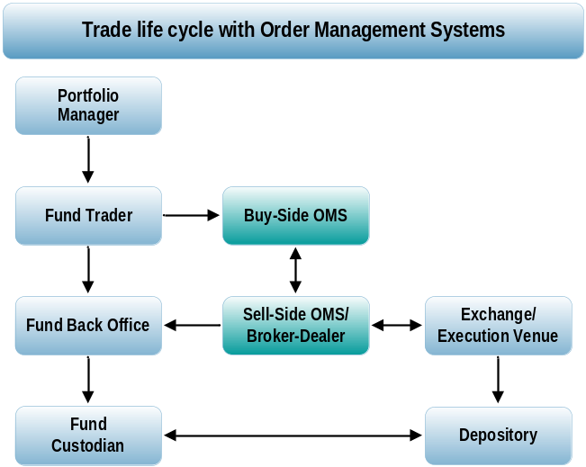
Figure 2: Trade life cycle with Order Management Systems

The diagram above is an extension of Figure XXX and illustrates how an Order Management system fits into the life cycle of a trade.

Earlier the sole function of an OMS was to capture trade orders, route them either directly to the execution venues or through the sell-side OMS and finally record the notice of execution against the order placed. Functions like portfolio management, decision support, compliance, risk management were outside the purview of OMS.

Today, the OMS application has been fully integrated with the upstream functions like portfolio modeling, pre-trade compliance and downstream functions like post-trade compliance, reporting tools etc. The actual features of an OMS used by a firm can vary depending on the parameters like size and complexity of trade, nature of asset classes etc.

For ease of understanding, the sections below have been divided into two broad groups – Core and Supporting features of OMS. However, the market today looks at an Order Management System as a complete product suite.

  - Core Features of OMS
The raison d’etre of an Order Management System is to help a portfolio manager create, route, track and process the trade orders using the best available execution venues. Before a portfolio manager can place his/her order, pre-trade and post-trade compliance checks are built into the trading logic to ensure that the trade doesn’t violate any investment restrictions/laws.

    - OMS Trade Compliance
Compliance is an integral part of any order management system. With the requirements from regulators increasing with each passing day, the necessity for a robust compliance system is inevitable. The purpose of compliance is to avoid fund investment & regulatory violations and protect reputation of the organization. Compliance acts as a catalyst for institutions by creating a mandate for adherence to regulation.

The compliance module of the Order Management System allows the users to define a flexible range of compliance rules for monitoring client and investment policy mandates. Rules can be defined in accordance with directive on investment spreads or in terms of user defined portfolio segments like instrument, sector, currency, country, etc.

The module can be used pro-actively to warn limit breaches at pre-trade entry stage. The module can also be used for post-trade compliance for limit breach/compliance reporting system with full audit (client limits as of historic date) and back dated reporting capabilities (compliance between user defined historic dates).

      - Pre-trade compliance
Pre-trade compliance is the first line of defense in the trading process. Pre-trade compliance solutions allow each trade to be tested before orders are actually executed. These programs are integrated into order or portfolio management systems where they run a variety of scenarios that flag any possible violations of the restrictions that are programmed into the system. If a stock or financial instrument within a portfolio violates guidelines, or pushes the overall content of the portfolio over an acceptable limit, the trader or manager is alerted by creation of an incident which is tracked to closure by a policy driven breach management procedure.

Pre-trade compliance checks can be configured to run automatically at the creation and allocation of an order. When users create orders and run compliance checks, a message is sent directly to the compliance engine to ensure the order and its allocation is compliant. Typically the following checks are done before the order is placed:

- Restrictions for accounts based on securities types
- Broker Restriction
- Sector Exposure/Restriction
- Manager Limit
- Cash buffer requirements for portfolios
- Restrictions on trading pledged securities

The compliance engine runs the check, stores the compliance data history, and sends a message back to the OMS alerting the user that the order is either compliant or in violation. The severity of the violation determines whether the trader can override the violation.

      - Post-trade compliance
Post-trade compliance acts as a safety net that captures any violations that are not apparent during the pre-trade compliance check. Pre-trade compliance checks the immediate compliance of the portfolio, whereas post-trade compliance seeks to verify if the compliance rules have been breached during execution after which the traded & settled positions are fed from the accounting systems. The overnight batch process would flag these violations & report them as incidents.

The compliance engine of the OMS should contain an extensive rules library, including rule sets defined by the major national regulatory agencies. These rules should be parameterized and reused in many contexts. Some of the post-trade compliance checks could be:

- Do not trade non –tradeable securities
Implies that the fund should not trade any ‘non- tradeable’ security as fed in the non tradeable list in the system database

- Restricted Securities & Issuers – Banned List
Implies that the fund should not trade in ‘Restricted Securities & Issuers’ security as fed in the band list in the system database

- Max 3 % in initial margin or option premium
Implies that the fund should not invest more than 3 % of fund value in initial margin in case of futures or option premium

- No Debt where Credit Rating =D
Implies that the fund should not invest in debt instruments where Credit Rating grade is D

- Sum of issuers greater than 7% NAV must not exceed 30%NAV
Implies that the sum of issuers greater than 7 % in the given fund should not exceed a cumulative of 30 % of the total fund NAV

- Min Avg Credit Rating of Portfolio BB-
Implies that the Min Avg Credit Rating of the fund as per the Avg Rating Credit Analytic should be atleast BB-

- No Short Sales
Implies that the fund should not subscribe to Short Sales

- Max 8% in OTC securities per counterparty
Implies that the fund should not invest more than 8 % of the fund value in OTC securities for every counterparty that it trades with

- Fund may not invest in Real Estate , Precious Metals or Certificate for such metals or goods
Implies that the fund should not invest in real estate, precious metals or certificates associated with these sectors

- Max 40% in any single issue
Implies that the fund should invest a maximum of 40 % of fund value in any single issue

*Restriction Values in the rules stated above are indicative values for the sake of elaboration.

The compliance administrator/officer/manager can schedule the post-trade compliance check to run at the end of the day as a batch process or can run it at any point during the day.

      - Sample compliance rules
A sample set of compliance rules have been given below for the purpose of illustration. These rules can help one understand the compliance checks that are typically available in the Order Management System. Compliance rules are coded in the compliance system based on the business requirements /fund mandates/regulations as applicable to the OMS implementing organization. Rules may apply to specific category of funds e.g. equity funds, fixed income funds, a combination of the two etc. Universal rules may be created & placed in a rule hierarchy (rule template) which then may be applied to a specific fund. The rule when it is coded / entered into the system needs to be specified with the following: a. Override – Whether it can be overridden b.Scope - Applies for each fund or not c.Run – Pre & Post Trade d. Apply to – All Orders or Buy, Sell e. Applicable – From & To Dates. Actual set of rules can be very exhaustive and are outside the scope of this document.

- The module must allow access to all attributes (properties) of all classes of Assets, Portfolios, Positions, Transactions and Other Classes.
- Ability to set up restrictions that can be applied to all portfolios, such as:
  - Issue exposure limits, no more than certain percentage (usually 10%-12.5%) of any one firm without prior warning
  - Stop lists, e.g. Take-over closed periods.
  - Broker exposure limits in absolute terms or in relative terms, e.g. against the net asset value of fund or the value of all transactions in a time period.
- Support free creation of rules for checking investment guidelines.
- A user should be able to define if a rule is applied to a) positions, b) transactions or c) both positions and transactions
- A user should be able to define classes for rules a) to determine the severity of a breach, b) for administration purposes and c) for reporting purposes.
- A user should be able to check a rule adhoc (meaning without submitting the results of the check to the database) by selecting multiple portfolios or portfolio groups and by applying the rule on the positions and transactions of the selected portfolios.
- When the rules of a portfolio are checked, then both the positions and the transactions of the portfolio should be taken into account. You should be able to differentiate the effects of transactions on cash by the settlement dates of the transactions
- System must provide detailed reporting on restriction overrides.
- System must facilitate easy revision of order(s) when compliance violations occur.
- A user must be able to track compliance violations by: Portfolio/Security/Date/Severity/Manager/Length of time in violation relative to cure period.
- A portfolio manager can check whether potential transactions are in compliance with the investment guidelines by selecting n portfolios and sending potential transactions to the compliance software.
- The performance of the OMS must not be adversely affected by the time taken to carry out pre-trade compliance checks.
- Compliance officers need to be able to lift multiple violations in one step, applying the same comment over all violations
- System to provide easy to follow "look through" capability, e.g. rule violation pop up / alert, then drilling down to content, sub-portfolio / client, person assigned, disposition area, and manager sign-off, etc.
- User rights need to be granted by Portfolios/rule categories/activities.

    - Order Management
Order Management module is the heart of any Order Management System. All the other functions of an OMS are supporting to this Module. The key functions of the Order Management module are:

- Order Creation
- Order Routing
- Post-trade Processing

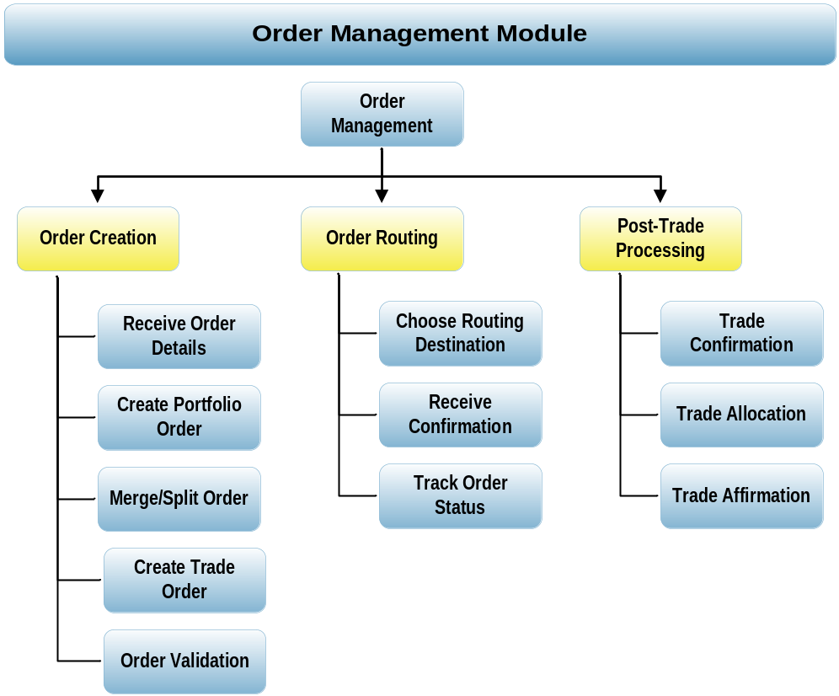
Figure 3: Components of the Order Management Module

      - Order Creation
Once the compliance checks have been fulfilled, the next step is to create the orders in the OMS. An order may be placed on the OMS for the following reasons:

- To invest the cash from a newly created fund account, based on the asset allocation model defined for the fund
- Portfolio rebalancing
- Fund termination/liquidation
- Addition/withdrawal of cash to/from the account

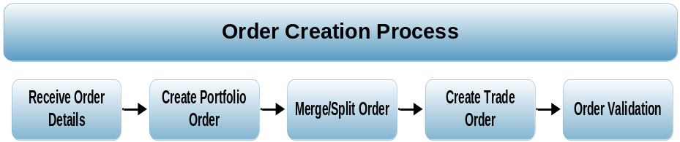

Receive Order Details– The fund manager will receive the order details from the portfolio manager through any of the following modes:
- Portfolio rebalancing, which is executed by the portfolio manager
- Automatically by importing orders placed by portfolio managers using other systems
- Manual communication channels

Create Portfolio Order
A single portfolio manager may be managing multiple funds or a group of client accounts. It is quite possible that the manager might want to trade in the same security with similar attributes, for multiple accounts. In such cases, the portfolio manager might combine the orders of two or more accounts and place a single order for the security. This is called a Portfolio/Basket Order.

Portfolio order is for multiple security and multiple accounts. This is created as a result of rebalancing or after usage of any other trading tool like what if, Raise Cash, etc. Portfolio orders can be either created through account rebalancing or manual entry. The Portfolio orders thus created are then checked for pre-trade compliance. Once the order is found to be compliant, it is sent to the trading desk for execution.

Merge/Split Order
Once the trading desk receives the portfolio orders, he/she can merge or split the orders and create a Block Order. Orders can be blocked based on the blocking rules defined by the user. Any combination of the attributes for an order can be combined to define blocking rules. For e.g., two orders with the same security ID and direction can be combined into a single order.

A manager places a buy order for 5000 shares of IBM for Fund A, and a buy order for 10,000 shares of IBM for Fund B. If the blocking rule is to block orders based on security ID and direction, the orders would be merged into a single block order for 15000 shares of IBM. Thus, depending on the blocking rule, these orders may appear individually or as a block.

The following operations may be performed by the trader for managing block orders.
- Touch – Touch is used to indicate that an order has been selected by a trader for blocking. When several traders are using a single order blotter, it is necessary to indicate if a trader is working on an order to avoid duplication.
- Merge/Unmerge – A trader can merge several orders into one block order or unmerge an existing block into several orders depending on the trading strategy followed.
- Edit – The details of the individual orders within a block order can be edited after the creation of the block. Only certain fields can be edited and modification of some basic details like side of the transaction etc. is not allowed.
- Reassign – The block order which has been assigned to a trader can be reassigned to another trader / trading desk
- Place on hold – The block can be put on hold so that it doesn’t get executed.
- Close and re-open – The blocks and orders can be closed if the trader feels cannot get executed. It can be re-opened again.
- Remove orders – Individual orders can be removed from the block order and the trader can work on it separately.

Multiple orders for separate funds would be expensive and inefficient for the investment management firm. Hence a block order could be placed to reduce the cost involved as well as the complexity of handling multiple orders. At the same time, if the order size is too large, it would move the market against the trader. Hence the optimum order size depends on the liquidity too.

Create Trade Order
The next step is to create a trade order in the system. At the time of order entry, the portfolio manager can choose from the following asset classes.
- Equities
- Fixed Income
- Options/Futures
- Rights and Warrants
- Mutual Funds
- Hedge Funds

The major components of the order entry process are
- Account Selection: Choosing the fund/client accounts for which the portfolio manager wishes to place a buy or sell order
- Transaction Type: Buy, Sell, Short Sale, Cover Short, IPO, Open/Close futures, Open/Close Forwards, Purchase/Exercise Options, Fixed Income Maturity
- Order Type (on price): Market, Limit, Stop, Stop Limit, Market on Open/Close
- Order Type (on time): Day order, Good till date, Good till cancelled, Extended Good till cancelled
- Order Type (on volume): Fill or Kill, All or None, Immediate or Cancel, Market not held order

Order entry can be based on the number of securities to buy/sell, number of contracts in case of options/futures or absolute nominal amount in the case of fixed income securities and funds.

In the case of manual order entry, the following information is required for creation of a new order.
- Account ID
- Security ID – A unique identifier for the security to be traded. It could be any one among CUSIP, SEDOL, ISIN, RIC, Common Code, Valoren etc.
- Transaction Type
- Quantity/Amount – Specifies the quantity of securities or nominal amount of fixed income securities that need to be bought or sold
- Order Type
- Time in Force or Validity
- Limit Price – Only for limit orders
- Validity Date – For GTD orders
- Destination
- Execution preferences, if any
The portfolio manager can also choose the trader and broker to work on the order.

Order Validation
Before the order can be finally routed to the execution system, basic validations are performed on the order to avoid erroneous order related information. If any of the entered details for mandatory fields are found not to be conforming to the rules specified, an exception is raised. The order details then need to be corrected before the order is submitted for processing.

The following are some of the validations that need to be performed:
- Short Sell – allowed only if last market price was an up tick.
- Quantity – should not be negative
- Limit Price – mandatory for limit orders (limit price cannot be beyond certain percentage of the market price for sell order and vice versa)
- Validity Date – Cannot be in the past, should be in the specified format
- Security – Should not be under the restricted list. Securities are restricted for trading for insiders after merger and acquisition activity, underwriting activity, and affiliate ownership in order to prevent premature selling that might adversely affect the company. Restricted stock cannot be sold without registration with the SEC (under the Securities Act of 1933) or some other special exemption.
- Broker/Route – Should not be restricted. A broker/route might be restricted, if the broker/route is not registered for a particular segment of the market.
- Buying Power – The account/fund should have sufficient buying power to perform a transaction

Features Supported by OMS
Some of the features of the Order Creation sub-module have been given for the purpose of illustration.

- The OMS pre-trade compliance has to provide detailed information on prohibited brokers at both portfolio and broker level.
- The system should indicate to a trader when an order contains portfolios that must be directed to specific brokers. In instances where an order contains portfolios that are “partially directed” (for example, 25% of all commissions) the trader should be provided with information at broker and portfolio level.
- To be available to a trader, a broker must be assigned to, or be made active to, a desk.
- Brokers should be further identified by purpose codes and if a desk does not have access to a particular purpose code, the desk should not be able to see that broker. Examples of purpose code - Block, Program, Small Order Flow, Soft, Algorithm, Syndicate, Directed, IPOs
- A trader should see a broker name as a combination of the broker name and purpose code, e.g. UBS - Directed, UBS – Algorithm, UBS - Soft, etc.
- A trader must be able to be split the order and place with multiple brokers.
- A trader must be able to submit the underlying portfolio allocations for a block order at the time of placement, e.g. for Korean and Taiwanese markets.
- The time, size and broker for each placement must be tracked.
- The system should allow a trader to delete / close any portion of an order that has not been placed.
- A trader must enter a reason to delete / close an order.
- The system should allow a trader to increase or decrease any portion of an order that has been placed, but not executed.
- If an order has been executed, but not confirmed, the trader should be able to delete the execution then delete the placement.
- When attempting to place an order, a trader should be informed if a broker limit (Counter party exposure) has been reached or is about to be reached.
- Orders should be placed with brokers for execution based on the transaction strategy and the resulting target volumes from broker voting.

      - Order Routing
Once the order is validated, it is then routed to the broker-dealer who would facilitate the execution of the order. The order is routed to the destination as chosen by the portfolio manager/trader at the time of order entry. This is done through FIX protocol (explained later); however SWIFT or other routing mechanisms may also be used.

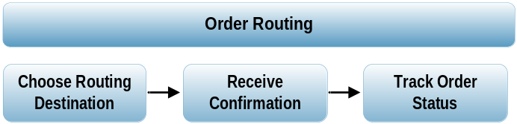

Choose Routing Destination
The order can be routed to Broker-Dealer or directly to execution venues like exchanges/ECNs etc. At times the trader may not want to specify a particular exchange but would want to get the order executed wherever it is possible to get best price. To support this, the OMS has a smart order routing algorithm defined which would route the order based on certain pre-defined rules. If the user does not specify the route or destination, the order is routed based on the routing algorithm. For e.g., if the security is available at more than one destination, the destination where the best bid or ask price is quoted will be selected. The user can also define a preferred broker or preferred destination, which is chosen in case the price offered, is the same across two or more routes.

The OMS should have built-in rules to make sure that best execution rules are adhered to properly and any violation whatsoever is notified, so that corrective measures can be taken at the earliest. Some of the best execution rules are:
- Executing a customer order, a firm should treat customers fairly - both in relation to the execution of other customer orders and in relation to its own proprietary trading
- Executing an order in a timely fashion and obtaining a fair price for the customer
- Execution of the order using the best Trading strategy
- OMS gives the facility to set Client definable workflows and breach record content for analysis and resolution. It also provides access to historical compliance exception reports and breach records. It publishes Breach register universe comparison reporting and trend analysis. Thus any violation in the Best Execution rules is brought to the notice of the compliance officers.

Receive Confirmation
Once the order is accepted at the routed destination, a confirmation of the receipt of the order is received from the destination. Once the confirmation has been updated, the system starts tracking the order.

Track Order Status
An order blotter is used to track the status of the orders. An order blotter is a structured display of all the orders and their statuses, both manual and electronic. Apart from the order status, the order blotter also displays
- Order ID
- Symbol
- ISIN/CUSIP
- Side (Buy/Sell)
- Order Type
- Validity
- Order Quantity
- Executed Quantity
- Remaining/Open Quantity
- Route
- Average Price
- Order Status

All the fields in the order blotter are updated real-time. Whenever the order status changes, the rows would change color to signify a change in status. The views in the order blotter are customizable to suit the requirements of the trader. The order blotter should have facilities to

- create new orders
- view/modify/cancel existing orders
- split / merge orders
- assign orders to a particular trader
- progress of order execution (partial fills)

      - Post-Trade Processing

Trade Confirmation
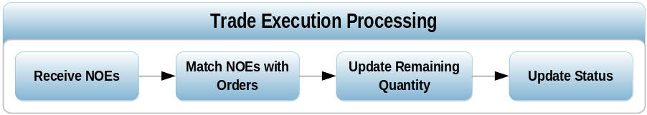

The broker-dealer gets the order executed through one of the execution venues and sends the Notices of Executions (NoEs) back to the buy-side. The NoEs sent by the broker-dealer is received by the FIX engine on the buy-side and the order statuses are updated. The NOEs are then matched with the orders using the order reference ID. The average price of execution is then calculated for the order.

For orders which have been placed directly on the exchange or other execution venues, the trades are received directly from the respective execution venues. The order blotter is dynamically updated with the details from these trade messages. The order could be completed in a single execution or multiple executions. Based on how it is executed, the order status changes from Open/New to either Filled / Completed or Partially Filled/Partially Completed based on how the order gets executed.

The following components are captured for trade execution processing.
- Trade ID – Unique identifier for each execution
- Order ID – Unique identifier for each trade order
- Execution Quantity – Quantity executed for each trade
- Execution Price – The price at which the trade was executed
- Executing Broker - Indicates the broker ID that was responsible for executing the trade. Usually it is the same as the designated broker, except for Step Out trades where the executing broker is different from the designated broker
- Broker – The clearing broker
- Time Stamp – Date and Time at which the trade got executed

Trade Allocation
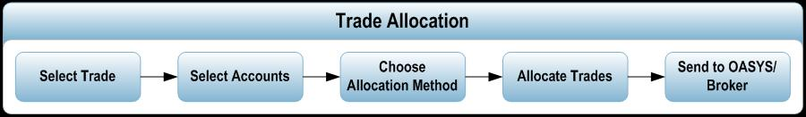

As described earlier, when a single investment manager is responsible for multiple fund accounts, the order for similar securities from such fund accounts are normally consolidated and sent to the trading desk. The trader can either place a single order for the portfolio order or merge/split several orders and send it as a block order for execution. Since a trade order is typically a block order on a security for multiple accounts or funds, when a notice of execution is received, it has to be allocated back to the accounts in the form of allocations.

Since trades from multiple funds are pooled into a single order, the firm must have a procedure in place to allocate the executed trade to the various funds.

Three different scenarios are possible for the allocation of quantity after the NOE is received
- Allocations are done as and when the NOEs are received
- The NOEs are held till the order is completely filled or till End of Day (in case it is partial). In this case the allocations are done as soon as an Order is fully executed. In case the order is only partially executed and the trading hours are over (i.e. no more executions are expected on that day) the allocations are created.
- The NOE are held till EOD (irrespective of partial fill, or when it gets filled). The execution price is the average price at which the orders are executed.

The trades can be allocated
- equally between selected funds
- on a pro-rata basis i.e. each account is allocated executions in proportion of the original order quantity
- on a random basis
- First In First Out – The earliest order gets filled first
- Last in First Out – The latest order gets filled first
- Specific Allocations based on special instructions from the portfolio manager
- Manual – This is a manual option where the trader decides the quantity to be allocated to each order

Allocations are done in round lots, as defined by the exchange for the security.

The determinants used by the portfolio manager to decide whether to allocate a particular trade to a fund or not are
- Overall market exposure of the fund
- Industry sector exposure
- Cash availability

Once the OMS receives the NOEs from the broker, the fund trader selects the NOEs that need to be allocated, and also the fund accounts to which the trades need to be allocated. Based on the instructions from the portfolio manager, the trader then allocates the trades to the selected fund accounts in one of the above mentioned ways. Normally the allocations are mentioned in either percentage terms or absolute terms.

Allocation information needs to be communicated by the fund trader to the broker-dealer. This can be done either before the trade or after the trade using FIX protocol or other external systems designed specifically for this purpose. Allocation can be communicated by the buy side firm using FIX in three different ways

- Pre-trade allocated order – where the allocation information is sent along with the order
- Pre-trade allocation – where the allocation information is sent as a separate message before the order is executed
- Post-trade allocation – where the allocation information is sent after the trade is executed.

The allocation process using FIX is explained in detail in section 2.6.4.
Allocations are sent either directly to the sell side or through specialized systems like OASYS. Many investment firms have not embraced automated allocations platforms and electronic trade confirmation services in the marketplace for reasons like:
- Cost involved in the initial implementation
- ongoing transaction fees
- Difficulty in integrating external proprietary platforms into internal processes; and, inadequate functionality to handle all types of instruments.

The information provided by the IM typically includes the
- IM’s account numbers or internal codes
- descriptions of the sub-accounts
- Alert codes to identify the sub-accounts.

The sell-side, in turn, uses an internal cross-reference account file to determine their internal account numbers for the sub-accounts. Once identified, the trades are then booked to each individual account, as stipulated by the IM.

Trade Affirmation
The process by which the two counterparties to a trade input their instructions to a central system which compares them and, if the instructions agree, confirms them and passes them on for settlement is known as Trade Confirmation. It is a document relating to a trade, which is sent to the client stating the details of the transaction (product, price, quantity, charges, proceeds, firm’s address etc.). A trade confirm sent to the client affirms that the transaction is good on the trade-date.

The affirmation process refers to the transmission of messages among investment firms, broker-dealers and the custodian banks regarding the terms of a trade executed for the institutional investor. Once the allocations are sent by the investment management firm to the broker-dealer, the broker-dealer submits the trade data to DTC. The DTC then forwards an electronic confirmation to the investment firm, the broker-dealer, the institution's settlement agent (if any), and other interested parties. The investment firm reviews the confirmation for accuracy. If accurate, the institution or its designated affirming agent affirms the trade. DTC then generates an affirmed confirmation and sends it to the broker-dealer and to the institution’s settlement agent.

The functionality for affirming the confirmations sent by DTC is sometimes provided by the OMS. The OMS receives the confirmations sent by the DTC, does a matching of the confirmations with the data available in the system, and then sends out the affirmation back to DTC. The final approval for sending the affirmation is typically given by the fund trader, who may check the details again manually before sending out an affirmation.

Trade confirmations are often formatted as a one pager and contain all details of the transaction. An example of a typical trade confirms format is as follows (there are several formats for trade confirms depending upon the requirement of the region/market, mode of delivery etc.)

Trade confirms can be broadly classified in two parts:
Pre-confirms: these are the initial statements sent to the client as soon as a transaction is done (time critical). Pre-confirms do not contain settlement instructions and hence are normally done in the Front Office.

Trade confirms / Contract Notes: these are statements that are often sent from Back office systems containing settlement instructions. Certain regions have specific requirements on the format for this document.

  - Supporting Features of OMS
    - Portfolio Management
Fund managers are interested in information that will affect the values of their portfolios. Managers use real-time information services to monitor changes in market conditions, with a view to rebalancing their portfolio to comply with the fund’s affiliated investment strategy. Traditionally, the fund manager’s main guide to his position has been his valuation report, which might display his current holdings in nominal, value and percentage terms. As technology advances, and data suppliers are able to provide key data such as index constituents and their weightings, fund manager tools are becoming increasingly sophisticated.

Using the portfolio modeling tools, the fund managers perform a hypothetical "what if" analysis across securities and assess the impact on the value of the fund. The manager also needs to forecast the cash availability as a result of his trades and finally generate the orders to the fund manager. A Portfolio Management module would typically support the some or all of the following of activities:

- Portfolio Modeling
- Portfolio Monitoring
- Cash management
- Performance Measurement
- Performance Attribution
- Order Generation
- Order Cancellation / Modification
- PM-Level Order Strategy/Management

      - Portfolio Modeling
The comprehensive modeling and rebalancing capabilities within the Portfolio Manager Workstation facilitate automated rebalancing of portfolios against complex and flexible strategies. Specifically, the tools provide for event-driven and ‘push-oriented’ compliance checking and order generation in a very high volume context. For example, if a Portfolio Manager needs to rebalance only those portfolios where divergence exists between actual and target weights in the equity asset class, this can be achieved in one-step. Such flexibility is particularly useful for those organizations adopting separately managed (or multi-manager) strategies. The solution’s efficiency is provided as a result of the key data being perpetually available, online. Orders are automatically generated and sent to the fund manager to bring portfolios in line and are checked online for compliance with client constraints, market regulations and internal guidelines.

      - Portfolio Monitoring
Portfolio Monitoring contains ability for user to define limits and be notified as portfolio approaches or exceeds those limits and violations. The purpose is to present only those portfolios that require intervention and reasons for the same. It should have ability to adjust limits on an ad hoc basis. Limits and violations include:
- Total Cash Violation - The overall cash amount including trade date cash flows is out of predefined bandwidth
- Market Exposure Violation - The overall market exposure including derivatives is out of predefined bandwidth
- Duration band violation – portfolio duration (incl. derivatives) is outside given limits
- Derivatives cover violation – derivatives are not covered by sufficient liquidity/securities
- Minimum Rating Violation – one or more positions are below the minimum rating allowed for the portfolio
- Minimum Average Rating Violation – the weighted average rating of the portfolio is below the allowed rating
- Currency Account Violation - Currency Accounts is not in line with target
- Expected Tracking Error (TE) Violation - Expected TE (calculated or imported) is out of predefined bandwidth
- Asset Allocation Violation - Asset allocation of a balanced portfolio is outside of bandwidths

      - Cash Management
The Cash Management function provides comprehensive integrated cash management functionality. The module handles multi-currency cash movements arising from all transactions such as purchases, sales, placements, redemptions, income, expense, foreign currency transactions, transfers etc.

Present and projected cash balances can be viewed in real time enabling the portfolio managers to keep a close watch on liquidity and credit limits at pre-trade stage by generating cash projections on a simulated portfolio.

      - Performance Measurement
Performance measurement algorithms are applied for individual clients or groups of clients. Portfolio performance is compared against user selected benchmark indices (customized per client) over a user selected time interval on a continuous basis or with reference to milestone dates (inception, end of year, end of month, etc). The Performance Module interfaces with the Graphics Module to produce presentation quality graphs which can be included in the Client Report Book.

      - Performance Attribution
Performance attribution is based on a user defined classification scheme which allows users to define portfolio segments and composites which can vary with time. Performance attribution/contribution can then be determined across these segments. Users can also define composite Benchmarks based on a basket of standard indices with user defined weights which can vary over time. Performance attribution can be provided on an absolute or relative basis against related benchmarks for portfolio composites, segments and at security level. The effects of cash / fees / dividend / transaction movements are time weighted automatically for providing performance measurement over any time period net/gross of user defined movement types.

      - Order Generation
Order generation function allows the Portfolio Manager to create trading orders based on this analysis and simulations and send them to the fund manager for execution. Some of features provided are:

- All the orders generated should be tagged with pre-defined reason codes such as: Subscription, Redemption, Cash injection, Regional Allocation, Model Change, and Rebalance.
- Ability to enforce review of generated orders by another function for e.g. review by portfolio managers, if trades are generated by a specialize group.
- Ability to enter an order or orders for a single portfolio or a group of portfolios according to a predefined allocation per portfolio by: Shares/face amount, Market value, Percentage and basis points of portfolio.
- System should support Order Characteristics of: day order, Good Till cancel order, Stop Loss order, Limit order, Market Order and Contingent order.
- Generate orders from “simulated” orders created when undertaking modeling and what-if analysis.

      - Order Cancellation / Modification
For Order Cancellation and modification purpose the system has ability to enforce a process that allows only a portfolio manager to initiate/request cancellation or modification of an order. Originator must be forced to state a reason for the cancellation or modification. A portfolio manager should be able to:

- Change the limit price or add a limit price where there is none
- Remove a portfolio from the order (unexecuted/unplaced shares only)
- Increase/decrease the number of shares in the order (unexecuted/unplaced shares only)
- Cancel the balance of the order (unexecuted/unplaced shares only)

Once the trader accepts or rejects a change, the system will reflect the same. When a trader closes an order, the portfolio manager that placed the order is notified that the order has been cancelled. An order should be capable of being modified, provided the resultant number of shares does not reduce the executed number of shares.

      - PM-Level Order Strategy/Management
The system provides the portfolio manager the ability to take key decisions quickly for day-to-day trading activities. Some of the decision points are:

- Define what happens if one portfolio in a group of portfolios encounters a pre-trade compliance breach. E.g. “Wait until all portfolios are cleared” or “Go immediately with the portfolios that are good”.
- Group orders from different portfolios to ensure that all portfolios get the same execution.
- Ability to instruct a trader to split large orders to be traded over several days, to split orders by asset classes - today bonds, tomorrow European equity, etc, to accommodate temporary compliance breaches that occur during the several days it may take to execute a trade strategy.
- Ability to send small orders directly to an alternative, external trading system, bypassing the standard trading desk.

Based on the transaction characteristics, portfolio managers must be able to pool transaction into programs of orders and define strategies for each program.

    - Interface Requirements

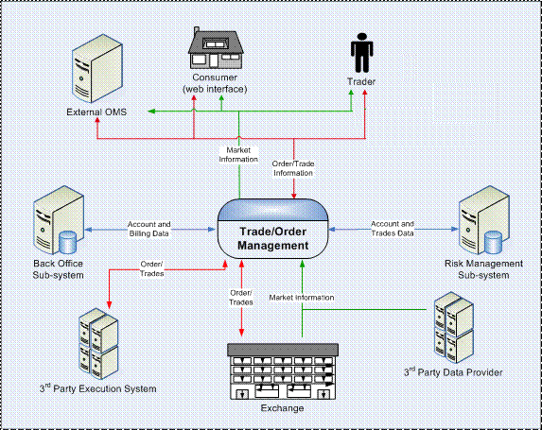
Figure 4: Order Management Ecosystem

The Order Management System interacts with various external entities for information and data exchange. The cluster of entities forms the Order Management Ecosystem. This ecosystem includes entities that will be involved in both outbound transfers involving sending data or messages to external systems as well as inbound transfers involving receipt of data feed from external systems into the Order Management System.

      - Interfaces to the Order Management System
Entities in the eco-system will interact with the OMS for the purpose of placing orders, viewing trades, creating allocations, viewing reports etc. The entities and their interface with the Order Management System are described below:

Trader
A Trader interfaces with the Order Management System to manage the client orders as well as their own portfolio (as a proprietary trader). A trader would exchange messages with the OMS to place, modify, cancel orders, to view executions, and view market data.

External Order Management Systems
External Order Management Systems (like sell-side OMS) interface with the Order Management System from a remote location using a standardized protocol. Orders placed from external order management systems will be either routed directly (STP) to the exchange or sent to the trader who can then route it to the exchange. Notice of executions will be sent back to the remote OMS electronically.

Back Office Sub-System
The Back Office subsystem is responsible for the post trade activities. This subsystem will be responsible for trade enrichment, clearing & settlement, reconciliation, trade cost analysis, post-trade compliance, corporate actions processing, cash management, position keeping, margin maintenance, commission processing, client and investor billing. It will also interact with other subsystems of Order Management System for getting relevant data (such as trades) and providing the relevant output (such as end of day positions, margins etc.)

Order Management System also interacts with the Back Office system for account related data. The account data would be stored with the Back Office. Order Management System would refer to it or send updates as and when required. In case of a separate Risk Management sub-system, Order Management System would pass on the account Data to it for risk and compliance evaluation, and receive exception reports. The account data includes demographics, positions, holdings, tax lots, performance, etc.

Risk Management Sub-System
The Risk Management sub-system is responsible for monitoring the trade activities. This sub-system will look after maintaining, monitoring, and reporting restrictions and compliance related information about each account and consumer. It would interact with other sub-systems of Trade/Order Management to get relevant data (such as orders placed, trades executed, and security information) and to provide the appropriate output (such as trading limits reached, compliance breach, margin call etc.)

Execution System
Exchange
Order Management System would have interfaces with different security exchanges, offering the functionality to place/modify/cancel orders for various types of securities traded at that exchange. The communication with exchanges will be either using a standard protocol like FIX or using the exchange specified protocol

Third Party Execution System
Order Management System would offer an interface to connect to third party execution platforms, other than exchanges using a standardized protocol.

Data Provider
Exchange
Order Management System would have interfaces with different security exchanges to accept security price feeds (real time security prices) as well as other security and index information (Market Data) such as bid/ask prices, market depth, trading volumes, exchange announcements etc that the exchange may offer.

Third Party Data Provider
Order Management System would offer an interface to connect to any third party provider (such as Bloomberg, Reuters etc.) using a standardized protocol for accepting market data – security and market information. Order Management System would receive feeds for real-time market data from the market data providers, with information about current prices of securities and the price depth. The data would be received in the exchange specific or standardized predefined formats multiple times in a day through proprietary APIs. This market data is used by the trading, valuation, and other such processes in Trade/Order Management.

Billing Data exchange
Trade/Order Management may receive billing/commission rates and schedules from external Back Office where clients use their own Billing system.

      - Interface Mechanisms
The exchange of information between the external entities and the Order Management System can be through real time messages or batch processing of files. Transfer of data will happen in real-time or at varying frequencies depending on the information being transferred and the requirements of Order Management System and the various external entities involved. This could range between transfers that happen several times during a day, daily or periodical transfers, and those happening on demand by any of the parties involved. For e.g. orders received from external systems will be on a real-time basis whereas end of day extracts to back office systems will be in a batch mode.

The transfers of data using messages follow certain protocols such as
- FIX (Financial Information eXchange protocol): For Orders, Trades and NOE messages
- Proprietary protocols/APIs: For transfer of messages between Trade/Order Management and external applications such as Back Office, Risk Management etc. At time orders may also be received in proprietary formats

      - Data Exchange in the Ecosystem
The ecosystem has a number of external entities interfacing with the Order Management System for the purpose of data exchange. Some of the examples of interaction have been listed below:

 | Type of Interaction | External Entity | Data Flow
 | Order and Trade Information | External Order Management System | Incoming
 | Client Order | External Risk Management System | Outgoing
 | Exchange Order | Exchanges, External execution, system | Outgoing
 | Trade Executions | Exchanges, External execution, system | Incoming
 | Trade Executions | External Order Management System | Outgoing
 | Trades | External Back Office System | Outgoing
 | Market Information | 3rd Party Data Provider, Exchange | Incoming
 | Order/Trade | 3rd Party Execution system such as TradeWeb , Bloomberg AllQ | Incoming/Outgoing
 | Accounting and Billing | Back Office system | Incoming/Outgoing
Table 1: Data Exchange in an ecosystem

Some of the typical interfaces supported by the OMS are:
- System should be able to import and export position information (including non-security type instruments such as FX forwards), cash balance information, position updates, list of approved securities, list of restricted securities, list of portfolio restrictions.
- Load data from multiple sources, e.g. loading positions from various accounting systems and compare loaded data with data loaded previously.
- Portfolio manager should be able to call Bloomberg from within system and use real time data to calculate analytics.
- Ability to export portfolios to optimizers, including what-if portfolios/scenarios, parts of portfolios, e.g. selected asset classes, benchmark positions and client restrictions.
- Ability to import and display results obtained from external risk systems, e.g. tracking error, VAR, simulations.
- Standard interfaces to optimizers/risk systems such as Algorithmic Risk Watch, Sunguard Monis for convertibles, etc.
- For trading it should be able to import orders from outside system.
- Standard Interface to Trade Web, Market Axess, Liquidnet, Ecrossnet
- Ability to create fax messages automatically to send allocations to brokers.
- Ability to receive trade confirmation, status updates from trade confirmation and matching system,
- Ability to interface to an external pre-compliance system.

    - Query and Reporting
Reporting is primarily driven by internal & external compliance rules, and customer requests. The reporting module in a trade order management system generates the necessary reports which can be either ad-hoc or periodic (end-of-day, end-of-month etc.) reports. Reporting tools simplify the communication of portfolio trading information, both externally to the brokers and custodians and internally within the firm. The module also allows customization of reports to meet specific requirements of internal and external users.

The reporting module provides full reporting support at each stage of the trading process. Traders, portfolio managers and compliance officers can view real-time portfolio holdings including proposed, pending and completed orders. A real-time cash monitor can be displayed at all times to guard against over-drafts. Trade tickets can be produced in either hard copy or electronic form. Compliance reports can be generated at any time and for any number of portfolios, independent of the order process. Other status reports are available to summarize broker placements, allocations and orders in process.

Some of the standard reports that are usually generated by the order management system are:
- End-of-day order list report – Lists all the valid orders that were placed during the day and routed to various destinations for execution.
- Realized gains/losses report – This report summarizes the gains and losses realized by each account based on the transactions performed during the day.
- Unrealized gains/losses report – This report summarizes the notional gains and losses, based to the day’s transactions.
- Exception reports – These reports list down the exceptions raised during the day’s transactions, orders rejected, the reasons for rejection, compliance rules violations etc.
- Commission analysis- Commission paid to the broker-dealers for execution, commission due, step-out / soft dollar arrangements etc. are mentioned in this report.

Some of the reports that are usually generated by the compliance system are:

- Rule Report –shows details of the rules as applicable for the selected account(s)
- Rule history- shows version history of the specified rule(s)
- Pre Trade /Post Trade status –shows details of the latest rule checks
- Rule Assignment-shows rules attached to funds
- Missing data – shows the missing data attributes that are necessary for evaluating the restrictions

Some of the typical features supported by the reporting module are:
- In selection the system must support consolidated reporting across portfolios, securities, products, user defined groups, user-defined selection of attributes, unlimited number of portfolios, securities, and other data per report.
- Ability to suppress selected data from appearing on report and allow user defined filtering for each report.
- Reporting contents should have option to display columns/rows with or without totals & subtotals, ability to customize headers & footers, support full multicurrency reporting, ability to add narrative/letter to reports.
- Reporting Content should be such that decomposition of collective or composite instruments is supported (mutual fund, index futures).
- In presentation standard chart functions such as bar, pie, line & scatter are available to represent data graphically
- In Production reporting tools should be able to generate batch output reports for any cycle:-Daily, Weekly, Monthly, Quarterly, Annual, Fiscal period, User defined period.
- Create reports ad-hoc, ability to create & save multiple report templates, ability to show date and time the reports were produced, ability to print immediately hardcopies of all online views.
- For efficient reporting delivery the tool should have ability to export reports to Excel spread sheet, ability to e-mail reports automatically including batch production, ability to fax reports automatically including batch production, ability to direct specific reports to specific terminals/locations/user-ids.

  - Order State Management System
Once an order has been placed in the system, it needs to be tracked. Tracking of the order is handled outside the Order Management System. An institutional investor typically has multiple Order Management Systems to support trading on different asset classes (equity, derivatives etc.) and for different types of trading (such as program trading, algorithmic trading). He/she has to check each OMS individually track all the order. Order State Managements Systems fulfill this business need. This application provides a centralized Order State Management functionality which can be used by multiple OMSs. This removes the duplication of this functionality in each OMS. Order State Managements Systems primarily provide two business functionalities:
- Maintaining the state of orders and associated fills, and distribution of order state information
- Providing order and trade details to any application that requests this information

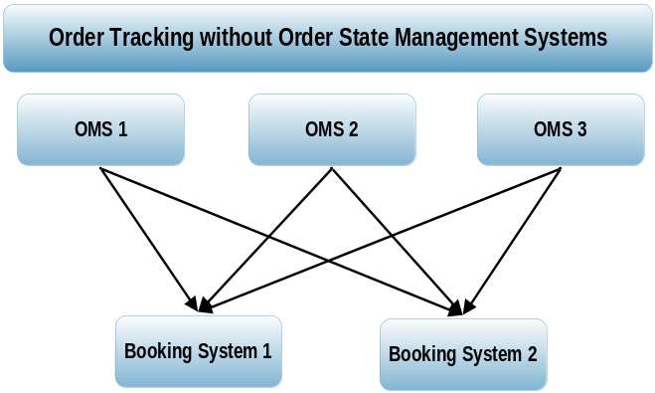

Figure 5: Order Tracking without Order State Management
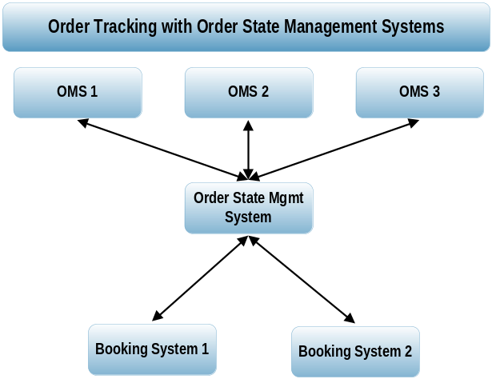

Figure 6: Order Tracking with Order State Management

Figures 4 and 5 illustrate how an Order State Management System can simplify the order tracking process. If there are M Order Management Systems and N booking systems then M*N connections would be required to track the order. An Order State Management System can simplify this process by reducing the number of connections to M+N.

The objectives of Order State Managements Systems are:
- To provide a shared Order State Management Service for use by a range of applications that need to deal with Orders and Executions
- To provide a set of components that can be used by Order creating and Order handling
- To provide a Message Bus based Enterprise Architecture for the creation, distribution and utilization of Order and Execution Information
- To provide a set of consistent Logical Views of Orders and Executions that can be used across applications
- To provide a set of message definitions and interactions that can be used by applications interested in Order and Execution information

The order state transition diagram describes the various possible transitions of an order during its life-cycle:

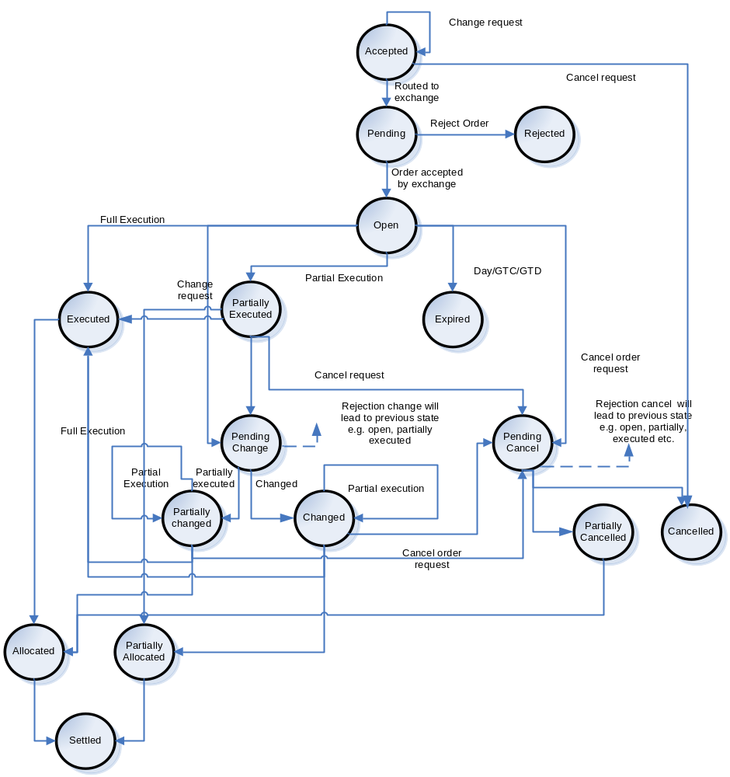
Figure 7: Order State Management System

ACCEPTED: This status is displayed when the Investment Manager (IM) places the order on the OMS. Once the IM confirms the order, various vetting rules (buying power, stock not being on restricted list etc.) are run on order. OMS accepts the order on successful validation of the vetting rules. Any modifications made at this stage are immediately reflected and the system displays ‘ACCEPTED’ status. On cancellation of the order, the system will display the ‘CANCELLED’ status

PENDING: This status is displayed as the order is routed to the exchange. The exchange too validates and vets the order before it accepts the order for execution. ‘PENDING’ status is displayed in the meantime. Once the order is accepted for execution by the exchange the status will change to ‘OPEN’

OPEN: ‘OPEN’ status indicates that the order is vetted and validated by the exchange and placed it in its order book. If the order quantity is fully filled (executed), the status is changed to ‘EXECUTED’.

If the order is partly filled then the status is changed to ‘PARTIALLY EXECUTED’ and the remaining order remains in the order book for execution.

If the order is a DAY/GTC/GTD and no match is found on the other side of the order book during the validity period, the order expires on the expiry date and status is changed to ‘EXPIRED’. This may happen in case of a limit/stop order

If the IM puts a request for changing or canceling the order the status is updated to ‘PENDING CHANGE’ and ‘PENDING CANCEL’ respectively and TOM sends a change/cancel request to the exchange.

REJECTED: If order fails on some validation rules at the exchange, than the exchange sends a “Rejected” message and the TOM changes the status to ‘REJECTED’.

EXECUTED: The status is shown when the whole order quantity is filled. Once the order gets allocated, the status is changed to ‘ALLOCATED’

PARTIALLY EXECUTED: The status is shown when the order quantity is partly filled. The non-filled part of the order remains in the order book for execution.

If the IM puts a request to change/ cancel the order, the status is corresponding updated to ‘PENDING CHANGE’ and ‘PENDING CANCEL’ respectively.

If the partially executed order gets fully executed, the status changes to ‘EXECUTED’

At the end of the day, filled part of the order could be allocated and the order status is updated to ‘PARTIALLY ALLOCATED’

EXPIRED: If the order is a GTC/GTD/Day and gets expired without finding a match on the other side of the order, the status is updated to ‘EXPIRED’

PENDING CHANGE: The status reflects scenario that the there is a request from the IM for changing the order. The exchange allows for changing the order if the order is unexecuted / partially executed. If the order is partially executed then the unexecuted part can be changed, the status reflected would be ‘PARTIALLY CHANGED’. This is very exchange specific. Some exchanges may not honor change requests for a partially filled order. If the order was not executed at all, then the status is updated to ‘CHANGED’.

If the exchange rejects the change request, the status is reverted to the previous status from which the change request was placed.
For e.g. if the change request was put from an open position, the order status would be reverted back to ‘OPEN’

PARTIALLY CHANGED: If the request for change for a partially executed order is accepted by the exchange, the status ‘PARTIALLY CHANGED’ is displayed. If partially changed order is again partially executed, the order status remains ‘PARTIALLY CHANGED’ until the whole quantity gets executed where the status is updated to ‘EXECUTED’. If the IM places a cancel request to cancel a partially changed order the order status is updated to ‘PENDING CANCEL’

CHANGED: If the exchange accepts the request for change of an unexecuted order, the order status is updated to ‘CHANGED’
If the IM places a cancel request to cancel a changed order the order status is updated to ‘PENDING CANCEL’

PENDING CANCEL: The status reflects scenario that the there is a request from the IM for canceling the order. The exchange allows for canceling the order if the order is unexecuted / partially executed. If the order is partially executed then the unexecuted part can be cancelled, the status reflected would be ‘PARTIALLY CANCELLED’. This is very exchange specific. Some exchanges may not honor cancel requests for a partially filled order. If the order was not executed at all, then the status is updated to ‘CANCELLED’.

If the exchange rejects the cancel request, the status is reverted to the previous status from which the cancel request was placed.
For e.g. if the cancel request was placed from an open position, the order status would be reverted back to ‘OPEN’

PARTIALLY CANCELLED: If the request for cancel for a partially executed order is accepted by the exchange, the status ‘PARTIALLY CANCELLED’ is displayed.

CANCELLED: If the exchange accepts the request for cancellation of an unexecuted order, the order status is updated to ‘CANCELLED’

ALLOCATED: This status reflects the scenario that the executed order is allocated according to the allocation instructions of the investment manager.

PARTIALLY ALLOCATED: Partially executed orders are allocated to accounts at the end of the day by pro-rata basis or other method specified by the investment manager. The status is accordingly updated to ‘PARTIALLY ALLOCATED’

SETTLED: On settlement of the transactions by the settlement cycle (T+3 for US), the status gets updated to ‘SETTLED’.

Sample Scenario 1:

Investment Manager places a buy order for 100 MSFT stock

The Trade Order Management vets the order and accepts it, the status changes to ‘ACCEPTED’. The order is routed to the exchange, the status changes to ‘PENDING’. The exchange vets the order and places it in its order book and sends an “Accepted Order” message to the TOM, the TOM in turn changes the status to ‘OPEN ’. Of the 100 stocks only 50 gets filled, the status changes to ‘PARTIALLY EXECUTED’. The IM puts a change quantity request for changing the unexecuted quantity from 50 to 30. The order status gets updated to ‘PENDING CHANGE’. If the exchange accepts the request, the status changes to ‘PARTIALLY CHANGED’. If of the 30, only 10 gets executed, the Order status is still maintained at ‘PARTIALLY CHANGED’, till the whole 30 gets filled after which the status is updated to ‘EXECUTED’.

After whole or partial execution as the case may be the status is updated to ‘ALLOCATED’ or ‘PARTIALLY ALLOCATED’ at the end of the day and to ‘SETTLED’ at T+3.

Sample Scenario 2:

Investment Manager places a buy order for 100 IBM stock

The Trade Order Management vets the order and accepts it, the status changes to ‘ACCEPTED’. The order is routed to the exchange, the status changes to ‘PENDING’. The exchange vets the order and places it in its order book, the status changes to ‘OPEN ’. Of the 100 stocks only 50 gets filled, the status changes to ‘PARTIALLY EXECUTED’. The IM puts a cancel quantity request for cancelling the unexecuted quantity. The order status gets updated to ‘PENDING CANCEL’. If the exchange rejects the request, the status returns to ‘PARTIALLY EXECUTED’. The IM puts a change order request to change the unexecuted order size from 50 to 30; the status gets updated to ‘PENDING CHANGE’. If the exchange accepts the change request, the status gets updated to ‘PARTIALLY CHANGED’. The IM puts a cancel request to cancel the order quantity of 30; the status gets updated to ‘PENDING CANCEL’. If the exchange accepts the request, the status gets updated to ‘PARTIALLY CANCELLED’

  - Reference Data Management
Reference Data is the static information that describe instruments (securities), accounts, clients, counter parties, custodians and represents the fundamental information which define and enable trading, clearing, settlement and custodial processes.

It is mostly static in nature and covers
- Clients – Identifier, Contact Data, Credit Profile, Preferences, etc
- Accounts – Account Numbers, Account Types, Account Status, etc
- Instruments – Identifiers (ISIN/CUSIP/SEDOL)Description, Attributes
- Counter-party Details (Broker/Dealer, Depository, Clearing Corporation, Custodian etc) – Account Numbers, Settlement Instructions, BIC/MIC codes, etc
- Commission, Fee and Taxes
- Holiday/Calendar Schedule – Market Holidays, Settlement Calendar, Market Trading Hours, etc
- Static data maintenance also includes - Currency , Credit Rating , Exchange , Market , Account Benchmarks etc

But now expanded to include
- Corporate actions – Notification data Attributes, Market information, etc.
- Market Data – Historical Prices, Fundamental Ratios, History

Relevance of Reference Data to the Transaction Lifecycle
Pre Trade
Research
Identification
Of interest
Order management
Execution
Management
Confirmations
& Allocations
Clearing
Settlement
Asset
Servicing
Content
Providers
Buy
Side
Sell Side
Execution
Venues
Custody/
Clearing
CSD
Ancillary Ref data
Location of trading
Location of settlement
Corporate actions
Market practice info
Other Asset service info
Entity Ref data
Counter party data
Entity identifier
CSD identifier
Clearing account
Client Data
Legal entity
Contact date
Credit profile
Account no.
Commission rates
Security Ref data
Instrument identifier
Descriptive data
Attributes
Rates/Codes
Calendars
Taxes
Source: Reuters, Cognizant analysis
Figure 8: Reference Data in Transaction Life Cycle

    - Information Captured
The Reference Data Management subsystem is responsible for creation and maintenance of the centralized data repository for the Order Management System. It is responsible for the processes involving setup or capture of the reference data entities such as users, customers, authorization and trading rules, security, market data etc. It is the set of detailed information that is referred to by the OMS.

Product information
- Product codes, descriptions
- Coupon information for convertible bonds
- Product classification

Client/ Counterparty Information
- Client codes, Names
- Detailed addresses, other contact details (telex, fax, Swift addresses)
- Commission rates, methods of commission calculations, Rebate information
- Client hierarchy details (Sub-account Vs Parent)
- Client’s preferences on trade processing attributes (price decimals, volume discounting eligible etc.)
- Client specific charges details

Market information (data related to various markets, exchanges)
- Market, exchange information
- Market specific charges details
- Market defaults (settle date cycle, charge types )

Settlement instructions (data that specifies where and how to settle the stocks and cash between parties)
- Client specific settlement information (place of stock settlement, cash settlement, bank information)
- Default settlement information
- Custodian information
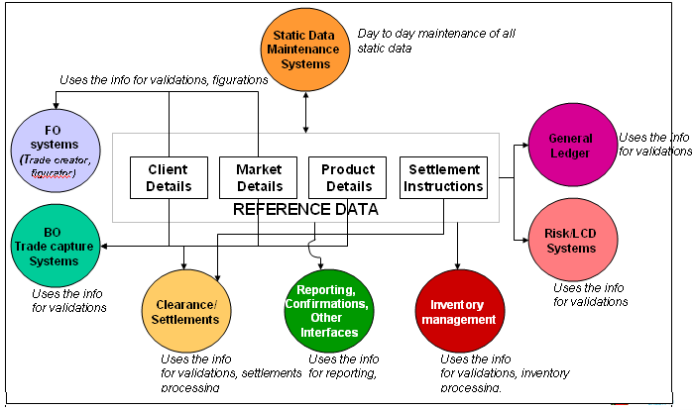

The Reference Data Management subsystem can further be broken down into the following Level 2 entities:

    - Customer Account Setup & Security Details Maintenance
This entity is responsible for the setup and maintenance of customers and accounts. The account is one of the base and most important entities in the system, as most of the order, trade, limits and position related information in the system is maintained for accounts and most of the transactions are on the account.

Account details maybe captured in a back office system and flow into Trade/Order Management as part of a start of day process or alternatively accounts may be created in the Trade/Order Management application using an administration module by the operations team.

    - Identity & Access
Identity management is about the end-to-end life cycle management of identities, where identities refer to users (administrators, traders, and sales), groups, clients and accounts.

Identity management will be using a Role Based Access Model where application modules/functions/reports/queries/data etc. are mapped to configurable roles. Users are then assigned to roles to determine the permissions that they have.

Topics that fall under identity management are:
- User/Work Group life cycle management
- Entitlement management (assigning rights & roles to identities)

Access management refers to the process of controlling and granting access to satisfy resource requests. Topics that fall under access management are:
- Authentication and Single Sign On (SSO)– Also known as fine grained security management
- Entitlement and Authorization (enforcing rights & roles)– Also known as coarse grained security management
- Security auditing (maintaining audit logs)
- Impersonation (do something on behalf of someone else)

    - Instrument/Market Data Setup & Maintenance
This Entity would be responsible for instrument/product setup and also for capturing market information such as instrument information (for multiple asset classes such as stocks, bonds, futures and options), index information (index composition, index values), market data such as bid/ask/close prices, market depth, etc. It is also responsible for archiving all the market information received by the system for future reference or analysis.

    - Miscellaneous Reference Data
This entity is responsible for setting up additional reference data that will be required for the application. This includes setting of master tables for exchanges, country and currency as well as maintaining information such as trading calendars, holiday schedules and so on

  - Users of OMS
Various lines of businesses (LOBs) within buy-side may have different requirements from a trade order management system. Though the primary functionality of managing and routing orders is common across the LOBs, there may be slight variations in the requirements from various LOBs.

Institutional / Mutual Funds
The requirements of institutions such as pension funds, investment trusts and mutual funds are fairly common. Order management systems allow institutions to quickly enter orders. After entry, all orders are put through extensive profile edits before being sent, which cuts down the amount of manual processing and ensures valid, accurate data is continually transmitted.

Some of the other reasons why institutions require and use order management systems are:
- Automatic production of order confirmations and registration records
- Automated exchanges
- Broker fail positions are automatically cleared on settlement date
- Order cutoff times can be established to help guard against late trading and market timing

Hedge Funds
Hedge funds are known for their technological as well as their investment savvy nature. In an order management system, hedge funds also require the flexibility to define multiple views and groupings of a fund’s positions. Hedge fund managers also need to view their positions grouped by strategy, sector or daily performance.

Managers also need to be armed with full multi-currency capability and be able to organize positions by three levels of strategy, and customize pricing rules down to the investment-type level.

Separately Managed Accounts
Since most managers manage SMA as well as non-SMA accounts, there is a compelling need for a centralized order management system using which they can effective manage their portfolios. The system should not only offer comprehensive tools for portfolio analysis, "what if" analysis, modeling, rebalancing, security swapping but should also offer features such as block management, trade rotation rules, drill-down capabilities and so on.

High Net worth
High net worth individuals are increasingly concerned with the management of their wealth and want a simpler, more coordinated process to protect and grow their assets. Therefore, in addition to an order management system having diverse capabilities and the latest features, the key need is ease of use. High net worth individuals want an order management system that is easy to get familiar with, and also one that has features that can be easily customized to their personal needs.

- Sell-Side Order Management System
Introduction

Order Capture
The most important function of an Order Management System is ‘Order Capture’. Order capture is done when orders are received to the sell side broker-dealer from Buy side Interfaces – e.g. Institutional clients, Brokers, Retail clients etc

Market Connectivity – Multiple instruments, multiple exchange connectivity

An Order Management System enables real time trading on the multiple markets it can connect to such as Exchanges, ECNs, ATS, brokers etc. A trader can do trading in various products (Equity, derivatives, bonds) and on various markets (Euronext, LSE etc).

Trader’s Workstation
Most Sell side OMS provide a variety of features that would enable a trader at the sell side form’s trading desk to make correct and timely trading decisions. The various features offered by such a system includes

Market watch that allows the trader to view bid-ask quotes for various instruments as well other market information such as volumes last traded price, market depth (i.e. the number of outstanding orders on .both bid and ask side for each security).

Additional trading features like fast trading (ability to place orders with minimum keyboard strokes), basket trading (ability to place orders for multiple securities simultaneously), program trading (generate and route orders based on pre-programmed trading tactics and strategies.

Trading tools to identify arbitrage opportunities and make trading decisions on derivative instruments.

Order/ History Management tools
An Order Management System maintains a history of all the orders placed by the system with the help of Trade Blotters. These blotters not provide detailed information on the status (whether executed, partially executed, rejected, modified, cancelled etc.) of various orders but also maintain the order history of a user (orders placed by a user) and also the history of the executions.

Order Routing
Another important function of an Order Management System is Order Routing, wherein the OMS routes the orders to the various traders, which in turn place the order on the exchange. It can even route an order to the different market places depending on which market gives the best deal. This is known as Smart Order Routing done using smart routing algorithms. Examples some popular Sell side OMS includes GL Trade, Fidessa, Davidge Data Systems, NYFIX etc.

  - Order And Execution Management

    - Types of Exchanges: Order / Quote driven
A stock exchange, share market or bourse is a corporation or mutual organization which provides facilities for stock brokers and traders, to trade company stocks and other securities. Types of stock exchange vary according to the type of trading objects; securities on stock exchanges, currency on foreign exchange markets, future contracts on future exchanges and interchangeable goods on commodities exchange. There are special stock markets for metal, sugar and cotton or for services such as freight, marine or insurance payments.

The stock exchange can also be classified depending upon the nature of trading

Order driven market
An auction market in which prices are determined by the publication of orders to buy and sell shares. In such a system there are no designated or official market makers but market makers nevertheless exist. When a buyer's bid meets a seller's offer (or vice versa) the stock exchange's matching system will decide that a deal has been executed.

An order driven market is one in which all of the orders of both buyers and sellers are displayed, detailing the price at which they are willing to buy or sell a security and the amount of the security that they are willing to buy or sell at that price. The biggest advantage to this system is its transparency: it clearly shows all of the market orders and what price people are willing to buy at or sell for. The drawback is that in an order driven market, there is no guarantee of order execution

Quote driven market
An electronic stock exchange system in which prices are determined from quotations made by market makers or dealers. This is also known as a "price driven market".

Quote driven markets only display the bid and ask offers of designated market makers, dealers or specialists. These market makers will post the bid and ask price that they are willing to accept at that time.

Even though individual orders are not seen in a quote driven market, the market maker will either fill your order from its own inventory or match you with another order. The major advantage of this type of market is the liquidity it presents as the market makers are required to meet their quoted prices either buying or selling. The major drawback of the quote driven market is that, unlike the order driven market, it does not show transparency in the market

Hybrid market
Hybrid market is the combination of Order driven market and quote driven market. It is a market which may show the current bid and ask prices of the market makers but also allow people to view all of the limit orders in the market.

There are two ways to display the limit orders on the order book

- Summary Depth – The orders of equal prices are bundled together irrespective of their entry time and displayed as single order with cumulative quantity
- Full Depth – All the orders in the order book are displayed i.e. orders with same prices are displayed separately.

    - Smart Order routing
Smart order routing is a term that can be used to mean a number of different things. However, in essence, smart order routing involves the automatic routing of a trade to a pre-determined execution destination.

With phone orders, smart order routing is not an issue as the investor can clearly communicate where the trade should be executed. However this same information needs to be made explicit when using electronic order routing and order management systems. This is largely a new challenge, as the predominance of national exchanges has until now resulted in default destinations for trade execution e.g. the local market. As competition hits the capital markets it is going to become crucial that electronic systems are able to automatically select the correct or preferred execution location. Ideally, such a solution would allow investors to specify the destination themselves, or enable them to ask the broker to determine the best execution venue.

Simple Smart Order Routing
At the simplest level, smart order routing allows the trader to enter an aggressive order for a stock, which can be executed across a number of different order books/exchanges. This enables the trader to be confident in the fact that the trade will execute on the order book that offers best price. If both order books can provide the stock at the best price, all of the business may execute against either order book. If neither exchange can fill the order at the best price, then smart order routing will ensure that the order is sourced from a combination of both books.

If either market can support the trade at the same price, simple smart order routing would also include basic functionality enabling the broker to select preferences in terms of where to leave a limit order or where to execute.

Advanced Smart Order Routing
Advanced smart order routing includes all of the components of simple smart order routing with the addition of pre-trade analysis, which considers the different pricing models of the competing exchanges in relation to the order being entered. This enables the broker to ensure that he is not only trading at the best price, but also incurring the lowest possible trading cost.

    - Direct Market Access (DMA)
Direct market access (DMA) tools permit buy-side traders to access liquidity pools and multiple execution venues directly, without intervention from a broker's trading desk.

DMA has been rapidly adapted by institutional traders as a method to aggregate liquidity that is fragmented across various execution venues. With DMA, buy side customers are renting a broker's infrastructure and clearing via the broker, but they are controlling the order. The real motivation for aggressive DMA trading on the buy side is cheaper commissions as compared to routing the order to sell side.

    - Algorithmic trading
A trading system that utilizes very advanced mathematical models for making transaction decisions in the financial markets. The strict rules built into the model attempt to determine the optimal time for an order to be placed that will cause the least amount of impact on a stock's price. Large blocks of shares are usually purchased by dividing the large share block into smaller lots and allowing the complex algorithms to decide when the smaller blocks are to be purchased.
The use of algorithmic trading is most commonly used by large institutional investors due to the large amount of shares they purchase everyday. Complex algorithms allow these investors to obtain the best possible price without significantly affecting the stock's price and increasing purchasing costs
Algorithmic trading may be used in any investment strategy, including market-making, inter-market spreading, arbitrage, or pure speculation (including trend following). The investment decision and implementation may be augmented at any stage with algorithmic support or may operate completely automatically.

    - Quote management
All the market markers need to open quote on the market making stock at the start of the day. On certain exchanges, it is mandatory to open the quote within certain time period during market open and needs to maintain the quote till market close down. These quotes can be altered (price & volume) depending upon the market situation. In the Hybrid market, the single leg of the quote (Buy or Sell) can be hit and executed individually. In this situation, the market maker has to refresh (or refill) the quote within certain time period to make sure it has provided the liquidity at any given time on that stock.

  - Trade Management
    - Trade Execution Processing
When the orders are matched at the exchange side, the executions are passed to the Sell side OMS. These executions are stored in the system in the form of trades. These trades are then passed to the settlement system for the final clearing. The off exchange trades should also be sent to the settlement system for the clearing.

    - Types of Trade Report
When a valid trade is entered in any Order management system as a part of trade execution different types of trade reports are generated. These can be for internal reports depending on the type of trade fill, or for sending to the exchange depending upon the requirement of that particular exchange where the trade is executed.

Reporting can be done based on the different types of trade that can be handled by an OMS. Each trade will have specific scenarios that will be assessed before the OMS decides how the trade is to be reported.

The trade reporting is dependant on the following main types of order fills:

Broker & Client Fills
These represent the firm trading with counterparty. This counterparty can either be a broker or directly the client.

House Fills
These are orders filled from the principal book. Every order has a defined executing book which should fill the order by default in case of house fills.
These fills can have extended functionality of automatic allocation to opposing orders. This can be done to ensure limit order protection.

Off exchange crosses
Off exchange crosses signify filling specified target orders by off exchange crossing with specified cross order (cross transactions)

    - Trade Booking
When the client order is entered in the system, trader fills the order by using various means like sending the order to exchange, fill it internally or get the execution from broker. Once the order is completely filled, these executions should be passed to the client. This process is called trade booking or client order booking. It is important to book the trade or client order so that at end of the day, traders wash or agency account should be flat (No stocks in agency account). Any position in the agency account signifies that there is a client order for which executions are not passed to the client. Without trade booking, trade allocation to the client account(s) will not be possible.

    - Trade Enrichment
All trades within the system are enriched with market charges, commissions, mark-ups, settlement date and sales credits.
Gross, net and net-net prices are maintained to provide a complete transaction within the front-office environment.

    - Trade Allocation
Trade allocation involves allocation of trades to eligible orders. Order management systems offer functionality to not only allocate these trades but also check the eligibility of the orders to be filled by a trade. The expanse of functions that a TOMS might offer is:
- Placing orders into different allocation categories
- Checking the eligibility of the order to be filled by a trade
- Checks on trade price and tolerances
- Calculating the quantities that can be allocated to eligible orders
- Allocation on house trading activities
- Move unallocated orders to a principal book after a particular configurable time period.

The quantities can be calculated using different algorithms like FIFO, price-time, or prorata.

Trades can be allocated manually or automatically. Manual allocations allow different allocation strategies to be tested before a particular allocation can be recorded

  - Position Management
    - Position Management
Position management is used for calculating, viewing and adjusting P&L information which results from trading activities. Some of the features of a position management system include:
- Track intraday positions for all customers and accounts and view positions and histories
- Provide real time data on trades, instrument prices and Exchange rates
- Manage cash constraints and compliance requirements
- Facilitating limits on trading, book, instruments and cash positions.
(http://www.portware.com/flash/files/what-do-you-want/position.html)

Types of Positions that a Position Management System should be able to support:

Trading Positions
These are the basic positions for trading and give the result of a single instrument trade on a single book. For each trading position P&L are calculated in a particular defined currency. Since the same instrument can be traded on many books, it can have a trade position on multiple books.

The attributes of a trading position are:
Position Currency – this is always set to the currency of the primary market on which the instrument is traded.
Current Position – This is updated as soon as any trade is entered. This is the quantity of any instrument at that point of time. The positions for any instrument can either be flat or long or short.

Position Management Systems also cater to trading position valuation, trading position marking, trading position adjustments and limits.

Settled Positions
After a trade is completed the security is delivered only on the settlement date defined by the trade. Hence, positions calculated by considering the settlement date, help track the quantity of instrument actually held at a particular point of time.

Corporate Actions
Actions taken by the issuer of an instrument like Dividends and Stock splits are called as Corporate Actions. Cash dividends paid on equities affect the P&L where a settled position is held on the instrument (equity). These payments and calculations should be automatically taken care of by the position management module of the order management system.

Similarly Stock splits affect the quantity of shares held. Any adjustment done by the OMS will reflect in both the trading as well as the settlement positions.

Book Positions
Books are used as a mechanism of accounting for trades and instruments. They are grouped together to form hierarchies which may reflect back office settlement systems and geographic or business lines. A consolidated single book position for each book will typically include:
- Long value, short value, net value
- Realized and unrealized profits, losses
- Accumulated charges

Limits can be set per book throughout the hierarchy. These limits can be set on net profit/loss or long/short values.

Depository Receipt Consolidation - (ADR /GDR)
For each trading book all the positions that are held in the depository receipt are consolidated, and give a measure of the exposure, profitability and arbitraged positions.

Summary Positions
Summary Positions are consolidated multiple trading positions of an instrument in different currencies in the default currency of that instrument, in a single book. It signifies the exposure and profitability for each instrument in the book.
These positions indicate
- the long, short and net cost
- Long, short and net value
- Realized, unrealized and net P&L
- Accumulated charges

Long value and short value limits can be configured to be set on the summary positions of the book with the help of the position management system of the OMS.

Cash Positions
The position management system should track the cash positions that are generated by trading in different currencies and values. These positions are generally calculated against the book currency to track book level P&L and also indicate the currency exposure. These positions typically have to summarize the net currency commitment to deliver or receive.
These positions also typically will summarize the exchange rate to book currency.
The P&L for each book is currency adjusted and will include P&L directly due to trading and indirectly as a result of exchange rate fluctuations.

Instrument Positions
All the positions held in an instrument are consolidated to give an overall instrument level view of the total position held. It can also be used to determine the long/short/net values, accumulated charges. It will also signify the realized and unrealized profit and loss for all the periods.

Cross currency Positions
This position measures the P&L resulting from exposure of currency against the exposure book currency. It helps measure the exposure due to cross currency trading. This normally occurs when the settlement is in a different currency than the book currency. These positions can be maintained separately in dedicated exposure books.

The position management system will typically help in tracking all these positions as well as also allowing viewing the top positions in terms of largest positions as filtered by different criteria. This allows risk monitoring of the filtered positions

    - Commission Management

Investment managers need to track how commissions are being used for trading, brokerage relationships, and proprietary and soft dollar research. Hence commission information needs to be captured, analyzed, and stored in a proper manner. Commissions are added to the trades after the NOEs are received from the brokers.
The commission type and the reason for commission are selected at the time of creating a portfolio order by the portfolio manager.
Commission for trades can be based on any of the following:
- Rate per share
- Flat rate for a trade
- Percentage Basis
- A mix of flat rate and percentage of amount or number of shares
- Based on number of trades
- Special arrangements

Along with choosing the commission type, the reason for paying commission to the broker is also mentioned. It could be
- Broker commission for executing the trade
- Step-out arrangement
- Research Services
- Direct Access

It could also be based on special arrangements such as step-out commissions or soft dollar services. Hence the OMS tracks commissions based on individual transactions, broker commissions, and also tracks the step-out and soft-dollar commissions.

Step-out Commissions
In a step-out trade, one brokerage firm executes an entire order, and then gives other firms a credit, or commission, for a specified piece of the trade.

The broker-dealer firm that would receive the step-out commission needs to be mentioned after allocations are done for a trade along with the quantity that needs to be stepped out.

The following are the components for calculating step-out commissions.

- Quantity
- Broker
- Reason

In a typical step-out arrangement, an adviser directs trades to a broker-dealer with the instruction that the broker-dealer execute the transaction and that another broker-dealer provide soft dollar products/services. The broker-dealer that provides the execution of the trade "steps out" of a portion of the commission in favor of the broker-dealer that provides the soft dollar product/service.

As mutual fund distribution becomes increasingly competitive, step-out trades have become an additional incentive used by fund advisers to reward broker-dealers for selling fund shares. By asking a broker executing a trade to step-out a portion of the commission to another broker, an adviser can use the broker that provides best execution to execute the trade, and can pay commissions on the trade to other brokers from which it receives research or other services, even if those brokers have inferior execution capability.

Soft Dollar Arrangements

An arrangement whereby the investment manager directs transactions to a broker, in exchange of which, the broker provides brokerage and research services to the investment manager. Soft dollar arrangements include proprietary and third party research arrangements but do not include directed brokerage arrangements. E.g., a mutual fund may offer to pay for research from a brokerage firm by executing trades at that brokerage.

After the allocation process, while calculating commissions, the broker with soft dollar arrangements with the firm can be chosen along with the reason for paying commission for the broker.

Since the early days of the brokerage industry, full-service broker-dealers have provided research and other services to customers in addition to executing trades as part of an overall package of services provided to customers. The costs of these services are not separately billed to customers of brokerage firms but instead are considered part of the overall service provided to customers.

    - Profit & Loss calculation
In order to calculate the profit and loss (P&L) for a given position, it is necessary to know the cost at which the purchase was made. If there are multiple purchases of the same security at different prices, the cost price for the sold securities needs to be ascertained for calculating the P&L. This can be done using one of the three methods mentioned below.

- Weighted Average Cost (WAC)
- First-in, First-out (FIFO) and
- Last-in, First-out (LIFO)

Weighted Average Cost method:
In WAC method, the average cost incurred to acquire a share in the position, is taken as the cost price to calculate P&L.
For example, if Templeton Equity fund has 1000 shares of GM motors acquired on 10 different trades of 100 each on 10 different trade dates, for maintaining positions based on WAC method,

Total cost incurred to acquire 1000 shares
Cost Price of GM share = ------------------------------------------------
1000

First-In, First-Out (FIFO)
In the FIFO method, purchase cost is ascertained based on the chronological sequence in which the securities were purchased. The cost of securities purchased the earliest would be taken first, and then the next lot etc.
For e.g., if 3000 shares of company ABC were purchased on 8th Aug at price X and another 4000 on 10th Aug at price Y, and 5000 shares were sold on 12th Aug at price Z, the P&L is calculated as follows
3000 * (Z-X) + 2000 * (Z-Y) would be the profit or loss of the transaction.

Last In First Out (LIFO)
In the LIFO method, purchase cost is ascertained based in the reverse chronological sequence in which the securities were purchased. The cost of securities purchased the latest would be taken first, and then the previous lot etc.
For e.g., if 3000 shares of company ABC were purchased on 8th Aug at price X and another 4000 on 10th Aug at price Y, and 5000 shares were sold on 12th Aug at price Z, the P&L is calculated as follows
4000 * (Z-Y) +1000 * (Z-X) would be the profit or loss of the transaction.
To give the right picture of the value of the positions and the profit or loss made by each account, both the realized as well as unrealized P&L should be calculated.
Realized P&L is the actual P&L which arises as a result of
- The sale of a long position
- Covering a short position

Realized P&L is calculated as Quantity of Securities Sold * (Sale Price – Purchase Price) where purchase price is taken based on one of the methods described above

Unrealized P&L is the notional value that arises as a result of revaluing a long or short position based on the current market prices. It is calculated based on the closing prices of the security at the end of each trading day. It can be maintained either on an incremental basis, where only the profit or loss for the particular day is calculated, or reverse and re-post basis, where the P&L at the end of the previous day is replaced by today’s P&L based on today’s closing prices.

- Technology and Market Trends in OMS
  - SOA
A Service-Oriented Architecture (SOA) is essentially a collection of services. These services communicate with each other. The communication can involve either simple data passing or it could involve two or more services coordinating some activity. Some means of connecting services to each other is needed.

Services are repeatable tasks found within business processes. This task or function is well-defined, self-contained, and does not depend on the context or state of other services. SOA with its loosely coupled nature allows enterprises to plug in new services or upgrade existing services in a granular fashion to address the new business requirements, provides the option to make the services consumable across different channels, and exposes the existing enterprise and legacy applications as services, thereby safeguarding existing IT infrastructure investments.

Relevance of SOA for OMS

Vendors across the world are moving towards transposing their Trade Order Management System from N-tier architecture to a Service-Oriented Architecture. SOA allows the vendors to make their product robust and incorporate any new requirements that surface in the fast-paced trading world.

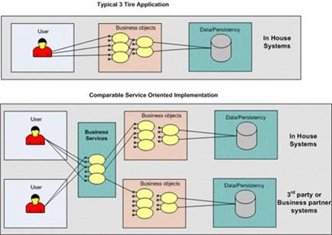
Source: http://www.intelligententerprise.com/
Figure 9: N-Tier vs. SOA Architecture

SOA enables the OMS vendors and their clients to leverage existing investments by allowing them to reuse existing applications, and promises interoperability between heterogeneous applications and technologies. SOA provides a level of flexibility that wasn't possible before in the sense that:
- Services are software components with well-defined interfaces that are implementation-independent. An important aspect of SOA is the separation of the service interface (the what) from its implementation (the how). Such services are consumed by clients that are not concerned with how these services will execute their requests.
- Services are self-contained (perform predetermined tasks) and loosely coupled (for independence)
- Services can be dynamically discovered
- Composite services can be built from aggregates of other services

Reference SOA architecture

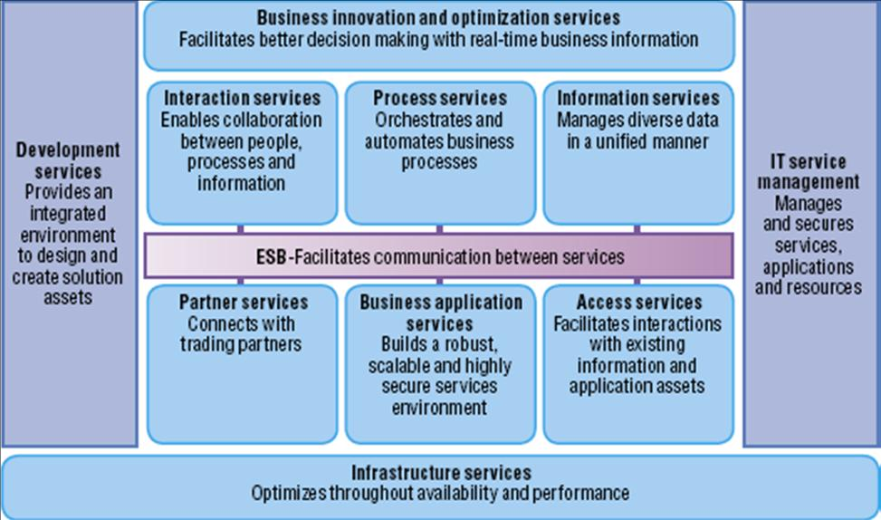
Source: www.ibm.com
Figure 10: Reference SOA Architecture

ESB (Enterprise Service Bus). The ESB delivers all of the interconnectivity capabilities required to use the services implemented across the entire architecture including transport, event and mediation services.

Interaction services: These services provide the capabilities required to deliver IT functions and data to users, meeting their specific preferences.

Process services: These services provide the control capabilities required to manage the flow and interactions of multiple services in ways that implement business processes.

Information services: These services provide the capabilities necessary to federate replicate and transform disparate data sources.

Access services: These services provide bridging capabilities between core applications, prepackaged applications, enterprise data stores and the ESB to incorporate services that are delivered through existing applications into an SOA.

Partner services: These services provide the document-, protocol- and partner-management capabilities for business processes that involve interactions with outside partners and suppliers.

Business application services: These run-time services include the necessary application components for the integrated system.

Infrastructure services: These services provide the ability to optimize throughput, availability and performance.

Manage
IT services management: These services provide capabilities related to scale and performance including edge services, clustering services and virtualization capabilities to allow efficient use of computing resources based on load patterns.

Assemble
Development services: During the assemble phase, tools for software architects enable them to model data, functional flows, system interactions and so on. Integration specialists can use these specialized tools to configure the interactions between services in business processes. IBM SOA Foundation provides tools for creating new services, enabling developers to create new business logic with little concern for the underlying platform.

  - STP on the Buy-side
Straight-through Processing ("STP") is a mechanism that automates the end-to-end processing of transactions of the financial instruments. It involves use of a single system to process or control all elements of the work-flow of a financial transaction, including what is commonly known as the Front, Middle, and Back office, and General Ledger. In other words, STP can be defined as electronically capturing and processing transactions in one pass, from the point of first ‘deal’ to final settlement.

In the traditional method, each and every transaction involves costly multiple data re-entry from paper documents and other sources which are susceptible to errors, discrepancies, delays and possible fraud. Further, the traditional means and methods of capturing and processing of information such as phone, fax, email etc. requires human intervention which slows the entire cycle, introduces errors and delays settlement.

Usage of STP enables orders to be processed, confirmed, cleared and settled in a shorter time period, more cost effectively and with fewer errors. Apart from compressing the clearing and settlement time, STP also provides a flexible, cost-effective infrastructure, which enables e-business expansion through real-time processing and access to enterprise data. STP also streamlines back-office activities, leading to fewer failures, lower risks and drastically reduces costs per transaction. It embraces a set of applications, business processes and standards, which are set to revolutionize the settlement and processing standards within the capital markets industry.

Benefits

- Facilitates shortening of the settlement cycle
- Increases transparency
- Avoids costly duplication of work and manual intervention
- Reduction in Risks and errors
- Faster data capturing, processing and report generation
- Increases the overall efficiencies
- Makes the market cost effective
- Better regulation by systematic audit trial

Achieving STP can have vastly different requirements for different entities. For example, the processes to be automated will be different for a brokerage firm than for a stock exchange, which has different requirements than a buy-side financial institution. And, while the focus of STP is frequently on the buy-side, the term still applies to virtually all parties involved in executing, clearing and settling securities transactions.

Analyses of the state of STP often focus on the various entities which contribute to the automation of securities trading, such as FIX, SWIFT, DTC, ISITC and others. However, the roles that these standards and entities play is constantly changing; generally towards expanding their scope of work in advancing STP. This trend has led to competition among standards and may ultimately lead to emergence of a single set of standards and clearly defined roles for remaining players.

History is yet another variable complicating the analysis of STP. The infrastructure which manages investment operations today is a result of evolution, not engineering. For instance, SEC has long advocated the concept of single national stock exchange. Yet regulation continues to support multiple exchange system. Regulation itself has been a result of evolution. With advent of financial futures, the SEC and the CFTC (Commodity Futures Trading Commission) have, at times, been in conflict. They divide, between them, regulation of financial instruments, each which can impact the value of those regulated by the other. Furthermore, these entities have had to work out disagreements as their regulatory jurisdictions.

Achieving STP on the Buy Side
A buy-side institution is attempting to meet or exceed established investment objectives as efficiently as possible with the best possible customer service. If the institution has achieved STP, trade modeling would be comprehensive enough to automatically adjust the portfolio to better meet objectives within compliance limits and seamlessly result in trade orders. The trade order management system would easily leverage all available venues for execution. Finally, executed orders would automatically result in accounting, performance, analytical and historical data facilitating investment monitoring, analysis, and reporting to management, regulators, and clients.

An STP environment should see a higher portion of labor devoted to portfolio management, analysis and trade modeling. Less labor would go toward trade affirmation, settlement, custodial reconciliation, front-to back-office system reconciliation, report production, and trade entry. The use of real-time information for flexible trade modeling and trade management would also result in more efficient use of cash. In short, STP would result in reduced overhead and better execution of portfolio strategies.

Steps in buy-side operations
Perform analysis to determine how best to meet investment objectives – This included economic, industry sector, and security-specific analysis. Such analysis is performed to achieve established investment objectives which may be dictated simply by the liabilities offsetting the assets or by an investment policy. These functions lead to dynamic model portfolio which may require addition adjustments for specific client criteria. The more efficiently this process is achieved, the more effective the firm will be meeting client objectives.

Model Trades – Trade modeling includes all the functions involved in determining how to adjust portfolio holding to better meet the objectives. This can be the purchase of a stock identified, through analysis as cheap, or simply adjusting the duration and/or convexity of the portfolio to better match the attributes of offsetting liabilities. This process is frequently stymied by a variety of factors which may include:

- Inability to identify favorable trade opportunities: This is as much a function of investment analysis as it is a function of trade modeling. If data cannot be sorted and analyzed on a timely basis against existing holdings, opportunities will be missed.
- Inadequate trade modeling facilities: Oftentimes, the rebalancing criteria can be complicated by special requirements for specific portfolios or requirements for maintaining sector weights across portfolios with vastly different total holdings. These complications can delay or possibly prevent the timely rebalancing of portfolios again result in missed opportunities.
- Inadequate ability to manage the effects of trading: Purchasing securities requires either the use of idle cash, borrowing, or the selling of another security. Active managers historically have required additional cash balances, and this is at least in part attributable to the shortcomings of their systems. Trade modeling is often not reflective of real-time positions and, frequently, is entirely separate from trade order management. Comprehensive trade modeling needs to consider and model for, the effects of trading in the remaining portfolio on a real-time basis.
Overcoming the system shortcomings often means adopting a simpler, but perhaps less effective, portfolio management strategy.

Manage the trade orders
Since trades cannot always be executed at one time and, instead, must be executed in separate fills, adequate trade order facilities must be available. Step-outs are sometimes required and additional rebalancing may dictate new trades before a given order is completely filled. Allocations of trades may need to follow different scenarios under different circumstances. Trade order management was once considered the point of initial entry. Now, some systems can take the results of trade modeling and create orders automatically. Automated links for electronically executing trades with counterparty’s also improves the trade order management process. The ability to manage all these functions efficiently has a tremendous bearing on the effectiveness of the firm in meeting its investment objectives.

Monitor and analyze holding against market conditions, liabilities, investments objectives, and restrictions: For each of steps 4 and 5, a tight integration of front-office trade management, modeling, and analysis systems with the back-office is critical to achieving STP. Timely review of current positions requires a reliable portfolio accounting system. Such a system must have facilities for timely automated reconciliation of holdings, trade affirmation, and settlement. Tight integration of front-and back-office systems improves execution of investment strategies and reduces overhead. It is with Steps 3 and 4 that we the tradition focus of STP on automating trades. Trade automation reduces trade risk and also reduces middle and back-office overhead.

Provide reporting to management, regulators and client: To effectively provide all the reporting and analysis, the portfolio accounting system must take minimal transactional data from the trading system, automatically pull data from external sources, and compute accounting, performance and compliance, and other data as well as automatically generate custom reports using either electronic or paper form

  - FIX Protocol
The Financial Information eXchange (FIX) is an electronic communications protocol developed for international real-time exchange of information related to the securities transactions and markets. It is a self-describing protocol which in many ways is similar to other self-describing protocols such as the newer XML. However largely because of its use and general acceptance FIX protocol remains much more common than XML in securities trading systems. The protocol is defined at two levels: session and application. The session level is concerned with the delivery of data while the application level defines business related data content.

The FIX protocol is a technical specification for electronic communication of trade-related messages. More precisely, the FIX protocol is a series of messaging specifications developed through the collaboration of banks, broker-dealers, exchanges, industry utilities and associations, institutional investors, and information technology providers from around the world. These market participants share a vision of a common, global language for automated trading of securities, derivatives, and other financial instruments. It is platform independent, so that it works on many types of computers and communication systems.

FIX is open and free, but is not software, hardware, network, programming language or a trading system. Rather, FIX is an enabling technology around which software developers can create commercial or open-source software, as they see fit. As the market's leading trade-communications protocol, FIX is integral to many order management and trading systems. Yet, its power is unobtrusive, as users of these systems can benefit from FIX without knowing the language itself.

FIX messages are formed from a number of fields, each field is a tag value pairing that is separated from the next field by a delimiter SOH. The TAG is a string representation of an integer that indicates the meaning of the field. The value is an array of bytes that hold a specific meaning for the particular TAG. E.g. TAG 48 is securityID and is a string that identifies the security; TAG 22 is IDSource and is an integer that indicates the identifier class being used. In the main the value is readable text however fields can be encrypted and thus the value can be pure binary and include the normal delimiter SOH - binary fields are always preceded by a length field. The FIX protocol defines meanings for most Tags and a range of Tags is reserved for private use between consenting parties.

The FIX protocol also defines sets of fields that make a particular message, within the set of fields some will be mandatory and others optional. The ordering of fields within the message is generally unimportant; however as noted length of encryption fields precede the encrypted fields also repeating groups are preceded by a count. The message is broken into three distinct sections: the head, body and tail. Fields must remain within the correct section and within each section the position may be important as fields can act as delimiters that stop one message from running into the next - the final field in any FIX message is TAG 10.

There are two main groups of messages - admin and application. The admin messages handle the basics of a FIX session. They allow for a session to be started and terminated and for recovery of missed messages. The application messages deal with the sending and receiving of trade-related information such as an order request or information on the current state and subsequent execution of that order.

Benefits of FIX
- Delivers information in real-time Delivers
- Provides platform and vendor independence Provides
- Eliminates proprietary interfaces and coding of multiple message formats which reduces amount of time to connect
- Guarantees order message delivery
- Supports data security (encryption)
- Supports multiple currencies and instrument types
- Allows for cost-effective connectivity

Complementing Industry Standards
- FIX is de facto the industry standard for IOI, pretrade, and trading activity. It is being developed by its users into the post trade and allocations space.
- FIX is not just equities, it is also very active in the Fixed Income and Derivatives space
- FIX is close to operating a certification plan for certain FI applications with important ramifications for equities & derivatives
- FIX has a memorandum of understanding with SWIFT to move toward ‘convergence’ with the ISO 15022 standard and is a very active participant of WG10
- FIX sees interoperability as an immediate and attainable goal and is working hard with related standards bodies to achieve this

  - Execution Management Systems
Introduction
Execution management systems (EMS) are desktop software applications that provide access to trading venues and facilitate & manage the execution of securities orders, typically through the FIX protocol. Often, they place a layer of intelligence over this access, containing features such as algorithms, market data and predictive technology.

Features
An EMS has three key features
- The trading blotter is composed of an order entry screen that serves to initiate and monitor trading activity. Users can access brokers' Direct Market Access (DMA) capabilities and algorithms to carry out electronic trading strategies, and the platforms offer both single-stock and portfolio trading capabilities. Most EMS platforms offer access to other asset classes besides equities because traders are clamoring for cross-asset-class trading capabilities.
- The EMS platforms offer connectivity to major exchanges, electronic communication networks (ECNs), alternative trading system (ATS) crossing networks, and multiple brokers. EMSs offer multiple destinations to which to route a trade.
- Real-time market data comes into the system from a combination of external feeds from exchanges and market data providers and, in some cases, internal proprietary data from the EMS provider. An EMS is typically built on an architecture that supports real-time market data and enables integration with other applications, such as analytics, black-box engines, and, in some instances, portfolio construction utilities

EMSs are traditionally lighter-weight systems, often run as ASPs from a vendor’s central database and focused on the type of analytics and data that hedge funds crave for such as position management from multiple prime brokers and intra-day realized and unrealized P&L. Because of their lightweight structures and heavy analytics, the first EMSs appealed to hedge funds and small asset managers that didn’t want to have to manage too much software in their data centers or have data centers at all.

EMS users tend to be traders who work directly with other traders and, increasingly, automated transaction networks. More than ever, managing orders across multiple trading destinations - such as exchanges, brokers, crossing networks and ECNs - has become an important feature of the EMS. Execution Management Systems tend to be less demanding on computers than OMSs and, as such, can be operated remotely by an offering broker on behalf of a buy-side trading client. Often, they are provided to clients for "free" by brokers, which subsidize the systems' maintenance with the buy side's soft-dollar payments for research and other broker services.

Evolution and Future Direction
The first EMSs were released a few years after the first OMSs, and their focus was strictly on execution in the US domestic equities market. These systems were spawned to serve the needs of day traders who required extremely fast and robust execution platforms. The early systems evolved into single-stock DMA applications, and many have subsequently added list- and basket-trading functionality. A second group of EMS solutions entered the market as a solution for basket and portfolio trading. Finally, a few of the broker-owned systems were built in-house to meet some of their specific business requirements.

Regardless of their roots, EMSs have morphed from execution-only tools to systems that provide a wider range of trading functionality. Across the board, traders are increasingly demanding near zero latency in market data and analytics engines, and the EMS has been designed with this requirement in mind.

Today's OMSs have largely emerged as portfolio management systems with functionality that ranges from pre-trade through post-trade support. The EMSs are really designed as trading blotters, an adjunct to one core piece of the OMS. EMSs will follow a path similar to that followed by OMSs and increase the breadth of their functionality, adding analytics, portfolio staging capabilities, and tighter systems integration. As a result, they will continue to be a substitute for an OMS among smaller asset management firms or hedge funds. At the same time, the success of EMSs has been a rallying cry For OMS vendors and Tower Group expects that OMS providers will invest in changes in the architecture of their systems to support integration of real-time market data. We also expect to see more investment to support the portfolio and algorithmic trading capabilities of traditional OMS Players.

  - Direct Market Access
Direct Market Access is an automated process of routing a securities order directly to an execution venue, therefore avoiding intervention by a third-party. Execution venues include exchanges, alternative trading systems, and electronic communication networks.

The buy side traders are looking to take more control of its trading decisions while looking for faster, lower-cost and anonymous executions. Direct market access (DMA) tools permit buy-side traders to access liquidity pools and multiple execution venues directly, without intervention from a broker's trading desk.

DMA has been rapidly adapted by institutional traders as a method to aggregate liquidity that is fragmented across U.S. execution venues. Buy-side customers, under regulatory pressure, are also seeking best execution and greater control over their trading strategies. With DMA, they are renting a broker's infrastructure and clearing via the broker, but they are controlling the order. The real motivation for aggressive DMA trading on the buy side is cheaper commissions - DMA commissions are about one cent a share, while program trades cost roughly two cents a share and block trades cost four cents to five cents per share.

Hedge funds are among the most aggressive users of DMA. Now that DMA has become commoditized, bulge-bracket firms are focusing on algorithmic trading - a higher-level strategy - as part of a comprehensive set of services encompassing DMA, program trading and traditional block trading, and on transaction-cost analysis services that they are putting on top of the DMA pipe.

To differentiate their services, brokers are expanding their DMA coverage beyond equities into fixed-income and derivatives. The next frontier is expanding DMA activity into the international markets by extending connectivity into Europe and Asia/Pacific.

Vendors
Goldman Sachs' REDIPlus, Morgan Stanley's Passport and CSFB's Pathfinder platforms offer global connectivity to equities, futures and options exchanges. Niche player NeoNet Securities offers direct access to European equity markets and to U.S. markets for European clients. Interactive Brokers (IB) is adding bond trading to its direct-access Universal platform and is using smart-routing technology to trade stocks, ETFs, options, futures and FX. Last year, Lava Trading launched a direct-access product for FX trading.

  - Convergence of OMS, EMS and DMA
As the structure of the markets has evolved and the pace of trading has increased, both by choice and circumstance, buy-side traders have taken greater control of their own destiny. The typical buy-side trader wears many different hats throughout the day – from execution specialist and tactician, accountant and statistician, to technologist and relationship manager. As the role of the trader has developed, the trader has demanded to have new and different tools at his or her disposal. Nowadays, traders’ arsenals commonly include order management systems (OMSs), execution management systems (EMSs), and direct market access (DMA) platforms. With more technology at their disposal, many traders are successfully managing the trading of an increasing number of securities. They are increasingly using low- and no-touch trading to leverage technology to achieve best execution. They are using technology to define that best execution with an increasingly diverse set of benchmarks and measuring that best execution with transaction cost analysis technology at increasingly small intervals. Technology is both driving and being driven by how traders are trading.

Today, many buy-side firms have a combination OMS, EMS and DMA. Compliance, reporting, allocation, clearing and commission management emerged as traditional OMS functions. EMS, by contrast, have excelled in custom transaction cost analysis, dynamic algorithms, order and execution automation, sell-side order handling, and portfolio and program trading. . Direct market access (DMA) tools permit buy-side traders to access liquidity pools and multiple execution venues directly, without intervention from a broker's trading desk.

Today interaction between OMS, EMS and DMA involves a complex shift of hands to a different system and screen rules. With no single "Holy Grail" of buy-side trading platforms in sight, says TABB Group in the interview-based research study released today, "OMS, EMS or DMA: The Future of the Desktop" there are a number of areas where Direct Market Access, Order Management System and Execution Management System platforms are in fact converging. Firms are looking at integrating these systems or having their own system with the objective of consolidating desktop space and get rid of the extra key strokes. Buy-Side firms are looking for seamless integration between the different types of functions.

According to TABB Group's report, in the near term, these platforms will offer multi-asset capabilities, have a base level of commission management and multi-broker functionality, offer a base level of trading ability at the single-stock and portfolio levels with access to custom and mass-market algorithms residing within both sets of blotters.

The specific needs of each shop will drive the adoption of one of the platforms.
- Traditional asset managers of any size will use an OMS to take advantage of its peripheral functionality. An asset manager who trades infrequently and is less concerned with speed of execution will be well served by an OMS, which still provides options for routing trades and provides the connectivity and compliance tools needed to manage their business successfully.
- A traditional asset manager who trades actively, engages in list or basket trading, and requires cross-asset-class trading capabilities will also implement one or more EMSs.
- Large traditional asset managers and hedge fund managers will choose to deploy DMA platforms to access liquidity pools and multiple execution venues directly, without intervention from a broker's trading desk.

Key findings of the The TABB Group report on Buy Side Trading Platforms: The Future of the Desktop report:
- 80% of the buy side firms require multiple trading platforms to execute their trades.
- The number of desktop platforms used by the buy side grew at a 42.6% CAGR between 2004 and 2006, but that number will decline at an 8.3% rate between 2006 and 2008.
- Platforms with the highest desktop penetration in the OMS, DMA and EMS categories are: Macgregor on 20% of desktops, RediPlus at 46% and Flextrade at 18%, respectively.
- 68% of the buy side is concerned about their OMS moving to a transactional/connectivity based pricing model.
- The lines between hedge funds and traditional asset managers continue to blur and the technology gap is shrinking—a 64% platform adoption difference in 2004 to 25% in 2006 and 7.8% in 2008.
- Half of firms with multiple disconnected platforms wish for a converged platform, versus only 30% of firms with integrated trading platforms.

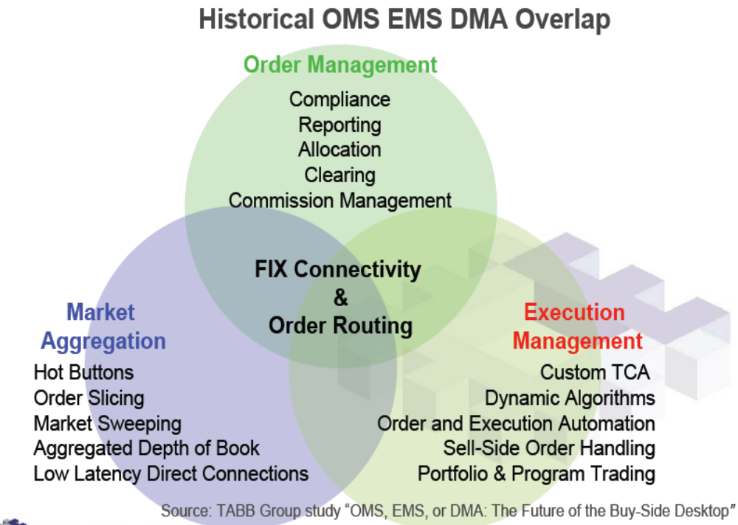
Figure 11: Historical OMS EMS DMS Overlap

This rationalization of systems is both encouraged and feared by the desktop platform vendors. Aspiring to capture more of the desktop, these vendors are enhancing their platforms, emulating the functionality of their competitors, while also trying to innovate. The relationship managers at the systems vendors and brokers providing this technology are becoming technology tutors and best execution coaches, constantly bringing the buy-side up to speed and working to increase the usage of their platforms. This emulation and overlap of functionality has led to the buzzword of the day—convergence. There are areas of the trading process where soon, the full range of desktop platforms– OMS, EMS, and DMA–will all be able to fill many of the same needs. This overlap and convergence in function has begun to reduce the number of platforms and is battling against the complexity of the buy-side desktop.

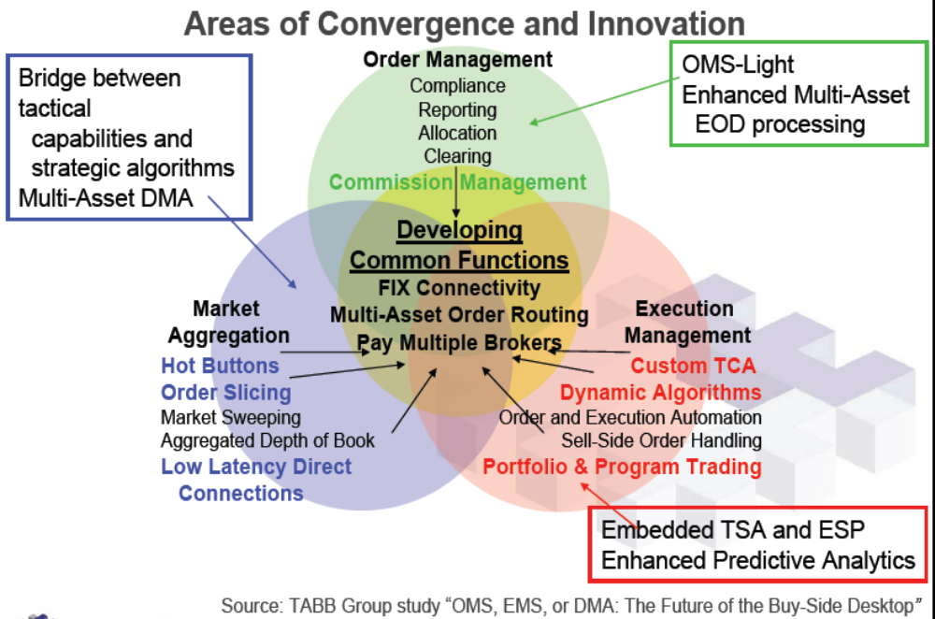
Figure 12: Areas of Convergence and Innovation

As these platforms try to converge, each of these vendors has the same goal— to control the buy-side desktop, to be the system of choice, and to own the relationship. However, that Holy Grail, the end-all and be-all of buy-side trading platforms, remains an elusive goal. All three platform classes—OMS, EMS, and DMA—all still have fundamentally different architectures and are serving different types of traders. While there will be a short list of vendors and brokers that will offer platforms covering the range of trading functionality, it seems clear that at least for the foreseeable future, universal convergence will remain in the realm of the Holy Grail—an ever elusive goal.

  - Regulation NMS, MiFID and their Impact on OMS
Regulation National Market System (RegNMS) and the Markets in Financial Instrument Directive (MiFID) will have far reaching impact on the functioning of the capital markets and its stakeholders. RegNMS is a regulation targeted at the US markets, while MiFID aims at the markets in the European Union. Both the regulations have been introduced to serve the same objective – protect the investor by ensuring best price on every execution.

Regulation National Market System (RegNMS)
Reg NMS stands as a transformational event in the history of the U.S. equity markets. It involves a major shift in the way trades will be executed from a business, operations, and technology perspective. The ultimate result will be beneficial for capital markets, but a sweeping regulatory change like Reg NMS requires significant investments from the market participants to revamp their systems, processes and procedures.

The Securities and Exchange Commission (SEC) proposed Reg NMS in order to modernize and strengthen the National Market System (NMS), the hub of the U.S. equity markets. Created over 30 years ago, the NMS was governed by antiquated rules that did not adequately address the complicated dynamics of today’s trading environment.

Markets in Financial Instrument Directive (MiFID)
The Market in Financial Instruments Directive (MiFID) aims to build a single, seamless financial services market in the European Union and would perhaps be the most far reaching financial reform ever undertaken. MiFID seeks to uphold the integrity and overall efficiency of the financial system and provide a coherent, risk-sensitive framework for regulating the order execution arrangements in the European financial markets.

MiFID would herald a new structure for the European financial markets by fragmented the market which will lead to a considerable loss of monopoly that the regulated exchanges currently enjoy. MiFID would also usher in increased revenue opportunities for players that are not regulated Exchanges. MiFID would fundamentally affect the way investment advice is currently handled and the way transactions are executed besides a substantial increase in regulatory reporting requirements. Identification, efficient usage and deployment of technology would be the critical success factor for any firm.

Implications of RegNMS and MiFID
Regulation National Market System and Market in Financial Instruments Directive will have a significant impact on the operations of the buy-side and sell-side firms. The obligation to provide best execution lies with all participants. However, the impact will be felt more on sell-side firms and exchanges than on buy-side. The foreseeable impact on market data is obvious. The volume of market data flowing through the pipes will rise significantly. Market data is estimated to grow as much as 10-fold as a result of these regulations. All companies will need considerably greater capacity and increase in computing power to support such a radical growth of market data.

Sell Side Implications
The sell side clearly carries the weight the regulations and its associated compliance on its shoulders. The demands on the broker/dealer community in terms of data management and retention as well as the time sequencing of that data impact their business in many ways
- Sell-side firms will not only need to upgrade their systems to identify best execution but, more importantly keep a proof of the execution for their clients and the regulatory bodies. This implies maintaining history of market data, orders and executed trades.
- Operationally, it will take tremendous effort to develop and institutionalize the policies and procedures required to satisfy future regulatory inquiries. Brokers/dealers must retain and recall the appropriate order and trade history required to reconstruct their decision making process.
- Technically, highly sophisticated tools are needed to demonstrate trade compliance. Sell side firms must synchronize their systems more closely with the exchanges in order to recreate the market conditions and order event trail for any given trade on any given day.

Buy Side Implications
The buy side implications are less significant than those of the sell side. As such, fund companies appear to be depending on brokers/dealers to handle regulation requirements and will probably do more business with those who are best prepared. However, there are issues that the buy side needs to tackle, primarily due to the increased amount of market data that will soon become a reality.
- Buy-side firms will need to upgrade their systems to be able provide transparency on all the available prices to investors.
- Operationally, new processes need to be put in place in order to manage the additional compliance burden. In addition, the trading desk must learn how to handle the new Reg NMS order types.
- Technically, it is unlikely that existing buy side infrastructures are adequate to remain competitive. As such, investments need to be made in new or significantly improved hardware, software, and connectivity bandwidth.

Challenges for the execution venues
Exchanges and ECNs will need to upgrade their systems to provide routing mechanisms to each other to enable best execution for buy- and sell-side companies. Exchanges have already started responding to this by buying ECNs, engaging in cross border consolidation / mergers of market places, all of which is spurring consolidation to gain advantage, at the minimum, of a better technology platform.

  - Best Execution
Best Execution refers to the responsibility of the brokers to provide the most advantageous or best price, order execution for customers. Many firms use automated systems to handle the orders they receive from their customers. In deciding how to execute orders, your broker has a duty to seek the best execution that is reasonably available for its customers' orders. That means your broker must evaluate the orders it receives from all customers in the aggregate and periodically assess which competing markets, market makers, or ECNs offer the most favorable terms of execution.

Best Execution comprises of three key elements: Price improvement, immediacy and liquidity. Whatever the ultimate goal of the investor, all three come into play, albeit to differing degrees. Price improvement is likely to be the priority for a passive index manager, with a lesser emphasis on immediacy and liquidity. But, an active, momentum investor such as a hedge fund manager probably values liquidity and immediacy over price improvement. With such varying objectives, it is, therefore, difficult not only for the investor and their intermediary to agree on a single definition, but also for regulators to apply a single metric.

The opportunity for "price improvement" – which is the opportunity, but not the guarantee, for an order to be executed at a better price than what is currently quoted publicly – is an important factor a broker should consider in executing its customers' orders. Other factors include the speed and the likelihood of execution.

Consider the trading process as it occurs every day at a large fund management company. A trader has an order to execute on behalf of his portfolio manager. To review the market, he first of all looks at the screens (and with the growth of alternative execution venues that can be quite a few screens which require an increasing level of interpretation). Then he makes a call to a broker. The trader is unlikely to tip his hand but the call will indicate to the broker a certain level of interest. The significance attached to the call will be a personal interpretation by the broker based on his knowledge of the stock, past dealings with that fund manager’s trader and all the other pieces of information, rumor and gossip in the air at the time. Depending on the importance he attaches to the call, the broker may let his market maker know and the market maker (depending on the position in his book) may change his view on the pricing. The broker may also take it into account in the next call he takes from another trader in how he describes the stock’s liquidity and its pricing and that in turn may influence the second trader in whether he wants to go to the market now or later. Our trader then calls broker number two and the same series of cause and effect starts over again. The fact that a deal is being contemplated is beginning to influence the market.

The trader has dropped a small stone into a still pool and the ripples are flowing out. A few minutes later our original trader executes the trade in that stock with another broker. Taking into account what is on the screen, what the brokers have told him and some of the quotes he has received, the trader picks a price and deals. Yet the ripples from that stone are still spreading outward and some of the alternative execution venues have yet to respond because they are further away from the centre. At the exact moment the deal is struck somewhere far away a better price clicks up on the screens.

Taking the current approach the trader has arguably failed in his obligation to achieve Best Execution (essentially has failed to be omnipresent and omnipotent) because at the moment he dealt there was a better price available somewhere else. Yet there is nothing really to criticize in the way the trader has gone about his task, merely a problem with the end (random) result. It is not being argued that the particular price achieved is random. It is a price that is struck as part of an informed decision-making process. What is random is whether that price represents Best Execution in the way we are being asked to consider it by European regulators. Under the SEC approach the focus would have been on whether the trader was doing all he reasonably could to stack the odds in his favor and create a record of so doing. This is an approach that fund managers will recognize because it is how they themselves try to get the best deal for the client.

Market fragmentation has probably made the trader’s life more difficult in the short term (even if there may be longer term benefits of competitiveness and innovation) because knowledge is more widely dispersed and it takes more time to canvas the entire possible demand for the order. Part of the problem with fragmentation is that you cannot merely add together all the alternative execution venues to get a picture of the market as a whole. Some venues are in actuality sub-sets of others. Yet others being relatively unregulated may be more prone to being unduly influenced by particular types of trade or participants.

A best execution policy should take the form of a process, or a more holistic framework, rather than of a rigid commercial or regulatory metric. Ideally, an asset manager should devise a trading strategy to maximize the chances of delivering maximum execution performance. Such a strategy would estimate the efficacy and costs of various implementation strategies before trading begins. It would also include a post-assessment of the actual versus estimated costs and use this information in a constant cycle of self improvement. This is of course a utopian vision of the perfect asset manager (using the perfect broker!) and we readily admit that any execution strategy is easier to wish for than to implement.

How to Achieve Best Execution
The proper way to achieve best execution is to conduct a pre-trade analysis and have an in-house system model the costs associated with trading to determine the efficient trade frontier. After the trade is completed, the post trade analysis should compare the results to the initial estimation.

Pre trade analysis
The goal of the Pre trade analysis is to define which strategy is the best for achieving best execution, which venues should be used, and which broker. High costs trade should be determined on a pre trade basis in order to be properly managed. This estimate can be driven either through historical comparisons if adequate data is available which may not be the case for illiquid securities when an in-house model has to be used.

It should be done through a modeling process, including several factors which drive the execution process, as follows:
- market capitalization
- daily trading volume
- average order size
- volatility of the stock which increases as a square root of time
- correlation between securities in the list of orders

The evaluation cost process should help determine the impact and opportunity costs. As optimizing market impact and opportunity costs management may require opposite decisions, the goal is to provide the best possible solution under the given circumstances. From a model perspective, the right solution is the one which sets the minimum costs for a constant level of risk, or sets for the same cost the lowest possible risk. As such, it should be possible to elaborate an Efficient Trade Frontier.

The strategy for implementing the investment decision will consist of making a choice between:

- Agency trading, where execution is a way for the buy side to pay for the services rendered by the sell side, including research and associated services and contacts with companies. Transactions shall result from an evaluation process involving all parties on the buy side, in order to direct to brokers a given amount of transactions. It is the manager’s responsibility to define and implement the criteria and appropriate process for ensuring that “best execution” determines broker relationships. In such a situation, the broker acts on a best efforts basis, and does not commit capital to execute the trade at a given price or for a precise volume and schedule.

- Principal: Execution is considered as a competitive business in itself, dissociated from the services paid to the sell side. The services are paid by third parties, or by the asset management company. The broker shall commit capital to execute trades for the funds at a given price or quantity, or within a certain schedule.

- The other way for the buy side firm to execute trades is through the access to specific liquidity pools such as electronic crossing networks or local Exchanges.

Post trade analysis
Post trade analysis provides comparison with pre trade analysis, and details the hidden costs associated with execution. It is related to the decision regarding the selection of the best benchmark.

The initial focus of regulatory authorities such as the SEC was on the best bid and offer, which made sense when spreads were wide, but this is no longer the situation for large caps.

VWAP, volume weighted average price is calculated by multiplying a stock transaction price by its share volume, adding all such transactions and dividing by the total shares traded. Statistics show that obtaining VWAP assures an above average execution level in the market.

But, as VWAP should be specific to a certain time span, it is difficult to determine to appropriate period without generating new discrepancies, because if the period considered is too short, the VWAP may be generated by the order itself. But the main negative effect of VWAP is that it may be manipulated by the trader, seeking to beat the benchmark without creating value for the fund.

Focusing on the sole average price may encourage traders to stick to it while due to the market momentum, the worst price of day D may be better than the best of D+1.The cost of opportunity for the portfolio would be huge.

Cost of Opportunity and delays:

Delays: In order to neutralize the effect of delays in the execution process, all orders are input and transmitted through the Order Management System. There are no delays between the portfolio manager and the trader and no delays between the trader and the broker unless they are part of the trading strategy. Funds are not penalized by late transmission of orders to the market, because the use of technology in the process does not allow for such delays.

Timing and strategy: For institutional orders, the benchmark used in the execution measurement process is relevant if it compares the trade actually realized with what it would have been within a short time span of several days positioned ahead and after the trade: it compares the execution with the price action of the market a couple of days ago, and a couple of days after the trade.

Errors, partial executions: Errors in the execution process are precisely monitored under the compliance officer scrutiny. They are taken out of the funds, so that the performance is not penalized and charged to the AM Company itself.

Partial executions are monitored by the compliance officer on a daily basis, and their cost is assessed within the measurement process, based upon the available price at the time of the transmission to the trading desk and the execution partially achieved over time.

Follow up, control and optimization of transaction costs analysis
In order to be relevant the in house evaluation shall be driven on a real time basis. Traders will have in mind all the trades’ conditions, and may explain or take into account all parameters for future trading. The measurement of the costs associated with the execution of transactions requires ensuring the availability of all relevant data. As such, it is necessary to run an Order Management System for all trades with the appropriate database administration organization having homogeneous data.

As costs of execution are tightly linked to the identity of the asset management company, depending on the kind of assets under management (invested in large caps, emerging…), the management style, the level of technology infused in the implementation process, it is very relevant to build an in-house model assessing the cost of transactions, especially on a pre trade basis.

But it is also relevant to use market benchmarks as well as external consultants such as Elkinns McSherry and or Best Executive Comparison Service. First, as there is no perfect methodology for evaluating the cost of trading, it makes sense to use alternative measures, and compare their results. It is also of major importance to be able to compare the data provided to other asset managers. One thing is to be clarified with the consultants: it is that they should get rid of data coming from trades executed on the sell side, because it may create strong discrepancies in the Evaluation of the performance.

Regarding clients requirements, it is better anyway to provide them with an independent analysis work conducted by an independent third party.
What matters is precisely the kind of service or benchmark which investor requires for analyzing transaction costs. Data should concern orders allocated per country, funds, brokers, traders as well as asset managers.

Even though there is no ideal methodology, several systems or benchmarks will probably show consistency, and it will be the main aim of the portfolio manager to enhance alpha using the data as an indicator, or a tool.

It is always beneficial to the AM Company to run such processes, as they are taken into account by consultants, as well as providing compliance officers with the appropriate report.

Need for Transaction Cost Analysis (TCA)
- A major reason for TCA's current upswing is that there's a general recognition on the buy side that lowering transaction costs can help boost investment returns.
- There is a need to have some qualitative and quantitative value assessment of who you trade with and why.
- If a buy-side firm is sitting down with a client or the SEC and they ask why broker X does 70 percent of your volume, you have to be able to answer the 'why’. Any prudent man or woman would want to see some form of analysis to lead you to conclude that a broker has earned that 70 percent market share.
- TCA empowers the buy side to grade the sell side - at least when it comes to this execution dynamic - with a degree of granularity
- The more sophisticated buy-side desks have adopted a leave-no-basis-point-behind approach to trading. They use TCA as a tool to capture more alpha [or extra market returns] on a regular basis, and that leads to a logical extension on how they actually allocate trades
- TCA is highly objective. It is data that is simply crunched and analyzed in its purest form to determine execution quality
- Whereas buy-side traders used to rely on paper-based reports reviewing trades monthly and quarterly, the new, so-called real-time TCA tools are integrated into the trader's front end. The management and senior traders want to know what is our real cost and how are we affecting alpha in the portfolio," "Traders want to know how much alpha are we missing - are we missing 30 basis points because the transaction costs were 30 basis points?"

- Major Vendors
  - Charles River IMS
The Charles River Investment Management System (Charles River IMS) is an award-winning software suite for all security types that streamlines, automates, and enhances investment management operations from decision support through settlement. Charles River IMS provides comprehensive tools portfolio managers, dealers and traders, operations, and compliance personnel require on one scalable platform. Whether deploying individual components or the full suite, investment managers can benefit from lower costs and risk and increased operational efficiencies complete trade cycle support.

The Charles River Investment Management System is a comprehensive front- and middle-office software suite for all asset classes, including Swaps and other derivatives, options, foreign exchange, fixed income and equities.

Charles River IMS incorporates real-time electronic trading via FIX through the secure, private Charles River Network based on the BT Radianz global financial extranet. The proven service-oriented architecture (SOA) of Charles River IMS supports 24 x 7 global operations, and combines state-of-the-art and industry standard technologies to ensure an open, flexible system that is scalable, functionally rich, and easy-to-use and integrate. Additionally, the company offers many services, including managed and implementation services.

Comprised of four seamlessly integrated modules (Charles River Manager, Charles River Trader, Charles River Compliance, and Charles River Post-Trade), Charles River IMS provides comprehensive functionality for portfolio management, trading, compliance, and centralized post-trade processing.

Key Features:
- Portfolio Rebalancing
- Modeling
- what if analysis
- multi-currency cash forecasting and analysis
- Ability analyze gain/loss and impact on projected income and taxes resulting from proposed trade
- Ability to select tax lots
- Automatic routing of orders
- Analytics on fixed income instruments
- Pre-Trade or Post Trade compliance
- Manage security and hedge exposure of portfolio
- Support for all asset classes (equity, fixed income, derivatives and foreign exchange)
- real time order trade status
- Support for FIX based network, ECNs, Alternative Trading Systems, Direct Market Access
- Rules-based automatic trade routing to confirmation / affirmation venues
- Configurable exception views and alerts enabling management by exception

  - Eze Castle Software
BNY ConvergEx Group's Eze Castle® Software (ECS) provides real-time, global multi-asset class investment technology to over 300 investment managers. The ECS OMS is a multi-asset, multi-currency system that supports intuitive trading workflows specific to the asset class you are trading. The components of the platform enable users to monitor and analyze portfolios, trade electronically, monitor multicurrency cash balances, run compliance checks, manage commission budgets, and integrate directly with internal systems and external third parties in real time.

Eze Castle Software's Product Suite includes:
- Multi-asset class, multi-strategy OMS
- Multi-asset class, multi-strategy portfolio analysis and modeling
- Pre- and post-trade compliance
- FIX electronic trading and execution system integration with over 330 destinations
- Algorithmic trading integration with 28 providers
- Seamless data integration with third-party systems
- Mobile connectivity to your OMS
- Commission and soft dollar management

  - Sungard Brass
Supporting a dynamic marketplace requires sell-side equity firms to invest in vastly functional and highly flexible technology. These firms look for technology that will save them time and money, but they also look for a proven record of positive response to new regulations and business requirements. SunGard’s BRASS Order Management System provides its customers with both the functionality they need today and the reliability they deserve to move confidently into the future.

BRASS helps its customers to drive revenue, increase efficiency and ensure compliance by providing automation tools, advanced integration capabilities and reporting functionalities. Through automating workflow and managing and routing orders, BRASS helps sell-side firms to focus more heavily on business strategy than on day-to-day operations. Detailed execution reporting, trade analytics and customer relationship management components further equip BRASS customers for continued success.
BRASS integrates with both third party and complementary SunGard trading solutions to provide a complete end-to-end, real-time trade and order management system. BRASS OMS helps clients to algorithmic trading strategies from leading providers complete with straight-through processing of trades, Direct Market Access and cutting edge compliance tools. And, BRASS’ module design helps enable its customers to fully customize the system to their specific needs – NASDAQ trading, sales trading, listed trading and listed market making alike.

  - Macgregor XIP
The Macgregor XIP Order Management Network is a broker-neutral, multi-asset class solution that combines powerful portfolio management, compliance, trading, and post-trade applications with a fully integrated and supported financial services IP network. Macgregor XIP enables buy-side firms to execute their investment decisions with increased speed, control, and efficiency, which results in improved performance.

Key Features
- Easily evaluate the impact “what-if” trades have on your portfolio with integrated, real-time market data and up-to-date portfolio information.
- Rebalance portfolios and generate all necessary orders in seconds.
- Save time appraising portfolio positions with fast, intuitive and multi-dimensional decision support tools
- Help prevent costly compliance violations with pre-trade checks of regulatory, company, and client-specific compliance guidelines
- Eliminate time-consuming ticket preparation
- Improve client support with the ability to provide real-time status updates

  - Moxy
Moxy® automates manual trading and order management processes, freeing up time for managers to watch the market and focus on trading and investment strategy. Moxy's more than 700 clients can attest to the fact that it's the most comprehensive trading and order management toolset in the marketplace. It tightly integrates with other applications to enable internal and external straight-through processing (STP) and to unite mission-critical functions throughout an organization.
This integration increases both productivity and profitability by eliminating the manual or duplicate efforts in the trading process.

Important features of Moxy include:
- Comprehensive instrument coverage for trading all security types
- Portfolio modeling, rebalancing and “what-if” scenarios
- Pre- and post-trade compliance checking
- Electronic order routing and trade execution
- Flexible allocation methodologies
- Real-time profit and loss monitoring and trading views
- Real-time messaging engine for seamless third party integration
- Rules-based smart order routing

  - Fidessa LatentZero
Fidessa LatentZero is the world's leading innovator in front office software for the asset management industry. We have set new standards for investment systems through our unique combination of business knowledge, market vision and technology innovation.

Capstone comprises Tesseract for portfolio manager decision support; Minerva for order and execution management (OEMS) and trading; Sentinel, the pioneer and market leading pre- and post-trade investment compliance system and OTC Derivatives Module

Capstone: Complete Front Office Solutions for Asset Managers
- Capstone is Fidessa LatentZero's complete investment management front office suite. Capstone comprises the following components:
- Tesseract - for portfolio analysis, scenario modeling and order generation
- Minerva - for order management and trading
- Sentinel - for pre and post-trade investment compliance
- EMS - fully integrated OMS/EMS solution
- Derivatives - workflow and trading tool for OTC derivatives
- Capstone can be implemented as a single, complete front-office product or customers can choose to implement any combination of the components.
- Capstone products can be fully and seamlessly integrated with existing front, middle and back office systems, regardless of technology or vendor.

Key Features
- Supports all asset classes including equities, equity derivatives, fixed income, OTC derivatives, money market and foreign exchange
- Fully integrated with real-time market data. APIs enable easy integration with other front and back office systems
- High performance and open, scalable technical architecture, supports multiple locations from a single data centre with 24x7 operation

Tesseract: For Portfolio Modeling and Decision Support
Tesseract is Fidessa LatentZero's decision support tool for portfolio managers, covering equities, fixed income, derivatives, money markets and currency. It enables portfolio managers to manage investment models, analyze portfolios against models and benchmarks, perform "what if" scenarios, and generate orders to achieve investment objectives.
Tesseract can be implemented as a single product, integrated with clients' existing systems, or as part of the Capstone suite alongside Minerva (order management and trading), and/or Sentinel (pre- and post-trade investment compliance).

Key Features
- High performance portfolio slice and dice by any combination of security attributes e.g. market, sector, currency, credit band, duration range etc
- Truly real-time valuation and P&L calculations with integration of real-time prices
- Comprehensive what-if analysis and order generation techniques for single security, switching, portfolio rebalancing and more

Minerva: For Order Management and Trading
Minerva is Fidessa LatentZero's order management and trading system for equities, fixed income, derivatives, money markets and currency. It is a truly real-time, 24x7 multi-location platform, with highly configurable workflows and tradescreens.

Minerva can be implemented as a single product, integrated with clients' existing systems, or as part of the Capstone suite alongside Tesseract (decision support for portfolio managers), and/or Sentinel (for pre- and post-trade investment compliance).

Key Features
- Full coverage of US, European, Japanese and Asian trading practices across all asset classes
- Unrivalled transaction throughput and scalability, with real-time integration of market data
- Connectivity to brokers via FIX and integration with all leading ECNs and ATSs

Sentinel
For Pre and Post Trade Compliance Management
Sentinel is the world's leading investment compliance system, providing comprehensive restriction checks at every stage of the investment process: pre-trade as part of the investment decision-making process, during trade execution, and post-trade.

Sentinel checks for breaches of client mandates, industry regulations and management controls across all asset classes. Its pre-configured rule libraries cover every major regulator around the world.
Sentinel can be implemented as a single product, integrated with clients' existing systems, or as part of the Capstone suite alongside Tesseract (decision support for portfolio managers), and/or Minerva (order management and trading).

Key Features
- Highest performance pre- and post-trade restriction checking of trade single and program orders
- Easy integration with all third party and in-house front and back office systems through published APIs.
- Comprehensive breach lifecycle resolution, workflow and reporting functions

EMS
Fidessa LatentZero’s market-leading Order Management System (OMS) Minerva has been extended to include Execution Management (EMS) capability, to provide the first truly integrated OMS/EMS system for the buy-side.

Minerva’s EMS module is completely broker neutral, with a high level of user configurability. It provides aggregated liquidity and instant access direct from the OMS blotter to DMA, broker algorithms, alternative trading systems, as well as broker care / principal orders. Support is provided for global markets for both single and list orders, including wave management, with real-time level 2 streaming data from Bloomberg, Reuters or broker-sponsored feeds.
Addition of Minerva EMS supersedes the inefficient and error-prone approach of “staging” orders from the OMS to one or more broker or third party EMS systems. Minerva EMS is installed as a simple, minor upgrade to the Minerva OMS.

Key Features
- Powerful OMS functionality and EMS capability within one system: no longer a need for separate OMS and EMS systems
- Tight process controls and integrated investment/trading compliance greatly reduce the risk of investment and trading errors
- Single audit trail of all OMS and EMS activity, with market data “price-stamps” provides a comprehensive platform for Best Execution audit and demonstration of MIFID compliance

  - Long View
The Longview Trading System (LVTS) is a fully integrated front-office trade order management solution for global buy-side institutions, which supports the business requirements and workflows of portfolio managers, traders, investment managers, and compliance officers.

LVTS offers advanced portfolio modeling, order generation, electronic trading, and compliance functionality. Line data’s scalable architecture and open relational database technology support 24x7 global trading and straight-through processing by providing seamless integration with accounting systems, settlement systems, data vendors, and other third-party applications.

Longview Trading is in production globally and deployed at over 100 Clients. Longview clients utilize the portfolio management, trading, and compliance functionality to meet workflow requirements, and adapt to ongoing business requirements.

Key Features
  - Multi-currency and multi-asset type
  - Customizable user interface for greatest ease-of-use and efficiency
  - Real-time architecture allowing for seamless integration with third-party applications
  - Portfolio management functionality that lets you create orders in seconds
  - Electronic trading to automate and streamline trading activities
  - Compliance functionality allows you to catch violations before they hit the trading desk
  - Client services including implementation, technical support, dedicated account management, and consulting

- Vendor Selection

Considerations When Purchasing an OMS
Purchasing an order management system should involve several departments within a firm - including IT, trading, portfolio management, compliance and executive officers. Each group should make a detailed list of required features for the OMS vendors to review. In addition to these features, the following are a few important issues to consider when buying an order management system.

Product Price
Order management systems are either bought or leased. Some vendors offer both options. If the system is purchased, expect a higher initial outlay, with monthly maintenance fees often as high as 20 – 25 % of the initial cost. Leased systems incur higher monthly premiums, but come with a lower initial cost. Also, when reviewing a vendor’s price list, be aware that there are often substantial installation and integration costs that may not be apparent.

Implementation Process
Implementation of an order management system often takes 3 to 6 months. The complexity of the installation and the vendor’s number of current or pending implementations often dictates implementation time. The best way to find out what the installation process involves is to contact other clients about their installation experience.

Support
Some order management systems are complex and require the investment manager to have a sophisticated IT department, while others are easier to install and maintain. Be sure to balance the sophistication of your IT staff with the sophistication required by the order management system. For a fee, several OMS vendors are willing to take on some of these IT requirements.

The size and quality of an OMS support staff often dictates how satisfied a manager is with the purchase of an order management system. Many OMS firms are smaller and may not have the resources for an effective support staff. Ask the vendor how many people they have on their help desk. Also, be sure to check client references on their ability to obtain support after the sale.

Third-Party Interfaces and Data Sharing
Firms need to think about how they will interact with the markets. Will they use crossing networks, algorithms, ECNs, DMAs or simply use FIX to connect to traditional brokers? For complete automation, the order management system must be integrated with a portfolio management system, execution venues, trust accounting system, risk management and other systems that require trade data. Many of these connections have already been built, but some connections must be developed. If the OMS does not currently have an interface, the vendor will offer to build one for a fee. Beware that being a beta user for a custom interface often involves a lot of time on the investment manager’s part. Ask current OMS users how well their interfaces work.

Transaction Cost Analysis Integration
Transaction cost analysis (TCA) tools analyze a firm’s executions by comparing them to specific benchmarks. The tools look at the executions by broker, trader and other metrics to measure how the buy-side trader is performing. These analytics try to analyze market impact, compare the trade execution to the portfolio manager’s instructions and examine the executions in conjunction with various portfolio or firm benchmarks. The end result of TCA should be a scorecard that helps a firm to better understand their strategies and the impact the strategies have on performance. As regulators place more emphasis on measuring best execution, it is important to monitor trade performance on a regular basis. By integrating with TCA services, order management systems now offer firms the ability to conduct their own trade performance evaluation.

- References
- www.wallstreeandtech.com/pfc/tom
- www.advancedtrading.com
- www.latentzero.com
- www.crd.com
- www.itg.com
- www.algorithmtrading.com
- www.computerdesign.co.uk
- www.ibm.com
- www.intelligententerprise.com
- www.fixprotocol.org
- www.fisd.net
- www.mddl.org
- www.securitiesindustry.com
- www.sungard.com
- www.ilog.com
- www.macgregor.com
- www.advent.com
- www.bloomberg.com
- www.ezecastlesoftware.com
- www.linedata.com
- MiFID supplement, by Banking Technology
- http://www.capco.com/uploadedfiles/MiFID_white_paper_29_Nov_05.pdf
- Preparing for MiFID-On your marks! Get set! Go!, by Bearing Point
- http://www.finextra.com/Finextra-downloads//featuredocs/MiFID_White%20Paper_v2.pdf
- MiFID key impacts, by Bearing Point
- http://isitceurope.org/fusion_public/doclib/1_050512%20MiFID%20Key%20Impacts.pdf
- The Complete Guide to Securities Transactions – Wayne Wagner – John Wiley & sons– 1989
- Trade secrets – Jack Willoughby – Institutional Investor Nov 1997
- Best Execution & Transaction Cost Analysis Summary – European Trader Forum –Nov 2001

- Annexure

  - Comparison of Vendors

 | Advent Software | Bloomberg | Charles River Development | Eza Castle | INData | Investment Technology Group | Latent Zero | LineData Services | Thomson
Investments Accommodated
EQUITIES/SHARES
Common Stock | x | x | x | x | x | x | x | x | x
Preferred Stock | x | x | x | x | x | x | x | x | x
Convertible Preferred Stock | x | x | x | x | x | x | x | x | x
Warrants | x | x | x | x | x | x | x | x | x
Rights | x | x | x | x | x | x | x | x | x
ADR (American Depository Receipts) | x | x | x | x | x | x | x | x | x
TREASURIES & AGENCIES
Treasury Bills | x | x | x | x | x | x | x | x | x
Treasury Notes | x | x | x | x | x | x | x | x | x
Treasury Bonds | x | x | x | x | x | x | x | x | x
Agency Debentures | x | x | x | x | x | x | x | x | x
Agency MTN (Medium Term Notes) | x | x | x | x | x | x | x | x | x
Agency Discount Notes | x | x | x | x | x | x | x | x | x
Zeroes (Zero Coupon Bonds) | x | x | x | x | x | x | x | x | x
Stripped Interest Only | x | x | x | x | x | x | x | x | x
Federal Funds | x | x | x | x | x | x | x | x | x
Inflation Indexed Bonds | x | x | x | x | x | x | x | x | x
CORPORATES
Investment Grade Corporate | x | x | x | x | x | x | x | x | x
High Yield Corporate | x | x | x | x | x | x | x | x | x
High Yield Corporate - Stepped Coupon | x | x | x | x | x | x | x | x | x
High Yield Corporate - PIK | x | x | x | x | x | x | x | x | x
Convertible Bonds | x | x | x | x | x | x | x | x | x
Yankee Bonds | x | x | x | x | x | x | x | x | x
Adjustable Rate Securities | x | x | x | x | x | x | x | x | x
MORTGAGE & ASSET BACKED SECURITIES
GNMA - Pass-Through | x | x | x | x | x | x | x | x | x
GNMA II’s - Pass-Through | x | x | x | x | x | x | x | x | x
FNMA - Pass-Through | x | x | x | x | x | x | x | x | x
FHLMC - Pass-Through | x | x | x | x | x | x | x | x | x
TBA’s (To Be Announced) |  | x | x |  | x | x | x | x | x
Dollar Rolls |  | x | x |  | x | x
Turnarounds |  | x | x |  |  | x
Pairoffs |  | x | x |  |  | x
CMO’s (Collateralized Mortgage Obligations) | x | x | x |  | x | x | x | x | x
REMIC’s (Real Estate Mortgage Investment Conduits) | x | x | x |  | x | x | x | x | x
Interest Only (IO’s) | x | x | x | x | x | x | x | x | x
Principal Only (PO’s) | x | x | x | x | x | x | x | x | x
ARM’s (Adjustable Rate Mortgages) | x | x | x | x | x | x | x | x | x
Commercial Mortgages | x | x | x | x | x | x | x | x | x
Whole Loans | x | x | x | x | x | x | x | x | x
Asset Backed Securities - Credit Card Receivables |  | x | x |  | x | x | x | x | x
Asset Backed Securities - Auto Loan Receivables |  | x | x |  | x | x | x | x | x
Asset Backed Securities- Other |  | x | x |  | x | x | x | x | x
SBA Loans (Small Business Administration) |  | x | x | x | x | x | x | x | x
MUNICIPAL BONDS
General Obligation Bonds | x | x | x | x | x | x | x | x | x
Revenue Bonds | x | x | x | x | x | x | x | x | x
Pre-Refunded Bonds | x | x | x | x | x | x | x | x | x
State & Municipal Agency Bonds | x | x | x | x | x | x | x | x | x
DERIVATIVE PRODUCTS
Financial Futures | x | x | x | x | x | x | x | x | x
Physical Futures | x | x | x | x | x | x | x | x | x
Index Products | x | x | x | x | x | x | x | x | x
Options On Futures | x | x | x | x | x | x | x | x | x
Options On Index Products | x | x | x | x | x | x | x | x | x
Options On Stock | x | x | x | x | x | x | x | x | x
OTC Options | x | x | x | x | x | x | x | x | x
Currency Options | x | x | x | x | x | x | x | x | x
Interest Rate Swaps | x | x | x | x | x | x | x | x | x
Equity Swaps | x | x | x | x | x | x | x | x | x
Currency Swaps | x | x | x | x | x | x | x | x | x
Swaptions | x | x | x | x | x | x | x |  | x
Credit Default Swaps | x | x | x | x | x | x | x | x | x
Total Return Swaps | x | x | x | x |  | x | x
Structured Products (CDO, CBO, etc.) | x | x |  | x |  | x
TAXABLE MONEY MARKETS/REPOS
Commercial Paper | x | x | x | x | x | x | x | x | x
Time Deposits | x | x | x | x | x | x | x | x | x
Bankers’ Acceptances | x | x | x | x | x | x | x | x | x
Term CD’s | x | x | x | x | x | x | x | x | x
Floating Rate CD’s | x | x | x | x | x | x | x | x | x
Repos | x | x | x | x | x | x | x | x | x
Reverse Repos | x | x | x | x | x | x | x | x | x
TAX-EXEMPT MONEY MARKETS | x | x | x | x | x | x | x | x | x
Tax-Exempt Commercial Paper | x | x | x | x | x | x | x | x | x
Variable Rate Demand Notes (VRDN) - Daily | x | x | x | x | x | x | x | x | x
Variable Rate Demand Notes (VRDN) - Weekly | x | x | x | x | x | x | x | x | x
Tax-Exempt Notes | x | x | x | x | x | x | x | x | x
FOREIGN
Currency Forwards | x | x | x | x | x | x | x | x | x
International Equities | x | x | x | x | x | x | x | x | x
International Futures | x | x | x | x | x | x | x | x | x
Foreign Bond Futures | x | x | x | x | x | x | x | x | x
Euro Bonds and Euro Notes | x | x | x | x | x | x | x | x | x
Brady Bonds | x | x | x | x | x | x | x | x | x
OTHER
Limited Partnerships | x | x | x | x |  | x | x | x | x
Hedge Funds | x | x | x | x | x | x | x | x | x
Private Equity | x | x | x | x |  | x | x | x | x
Real Estate | x | x | x | x | x | x | x | x | x
REIT’s (Real Estate Investment Trust) | x | x | x | x | x | x | x | x | x
Private Placements | x | x | x | x | x | x | x | x | x
Mutual Funds | x | x | x | x | x | x | x | x | x
Commodities | x | x | x | x | x | x | x | x | x
ORDERS AND TRADE EXECUTION
TRANSACTION PROCESSING
Buy/Sell | x | x | x | x | x | x | x | x | x
Short Sale/Cover Short Sale | x | x | x | x | x | x | x | x | x
Initial Public Offering | x | x | x | x | x | x | x | x | x
Open/Close Futures | x | x | x | x | x | x | x | x | x
Open/Close Forwards | x | x | x | x | x | x | x | x | x
Purchase/Exercise Options | x |  | x | x | x | x | x | x | x
Repo Collateral | x | x | x | x | x |  | x | x | x
Option Expiration | x |  | x | x | x | x | x | x | x
Foreign Exchange For Settlement | x | x | x | x | x | x | x | x | x
Foreign Exchange For Hedging | x | x | x | x | x | x | x | x | x
Fixed Income Maturity | x | x | x | x | x | x
Options Expiration | x | x | x | x | x | x
POSITION UPDATE AND MAINTENANCE
Tax Lot Level Processing | x | x | x | x | x | x | x | x | x
On-line Position Inquiry | x | x | x | x | x | x | x | x | x
CASH PROCESSING
Cash Balance Updating | x | x | x | x | x | x | x | x | x
Multicurrency Cash Balance Updating | x | x | x | x | x | x | x | x | x
Real-Time Cash Balance Updating | x | x | x | x | x | x | x | x | x
Monitor Cash Availability | x | x | x | x | x | x | x | x | x
Monitor Multicurrency Cash Availability | x | x | x | x | x | x | x | x | x
Automatic Generation Of Cash Transaction | x | x | x | x | x | x | x | x | x
Automatic Generation of FX Transaction | x |  | x | x | x | x | x | x | x
ORDER ENTRY AND ORDER ROUTING
Time Stamp Orders | x | x | x | x | x | x | x | x | x
Allow Order Entry Based On Shares | x | x | x | x | x | x | x | x | x
Allow Order Entry Based On Percentage | x | x | x | x | x | x | x | x | x
Allow Import Of Orders From Analytical System | x | x | x | x | x | x | x | x | x
Allow Import Of Orders From Proprietary Models | x | x | x | x | x | x | x | x | x
Allow Import of Orders From Another OMS | x | x | x | x | x | x | x | x | x
Allow Import Of Orders From Spreadsheets | x | x | x | x | x | x | x | x | x
Create Order Based On What-If Analysis | x | x | x | x | x | x | x | x | x
Route Order From Portfolio Manager To Trader | x | x | x | x | x | x | x | x | x
Special Instructions From Portfolio Manager To Trader | x | x | x | x | x | x | x | x | x
Pre-Trade Compliance At Time Of Order | x | x | x | x | x | x | x | x | x
Allows Trader To Route Order To Counterparty Via FIX | x | x | x | x | x | x | x | x | x
Displays FIX Connections On Screen With Icons | x |  | x | x | x | x | x | x | x
Icons Indicate When A FIX Connection Is Down | x |  | x | x | x | x | x | x | x
Allows Trader To Route Order To ECN | x | x | x | x | x | x | x | x | x
Allows Trader To Route Order To Alternative Trading Systems | x | x | x | x | x | x | x | x | x
Allows Trader To Route Order To Algorithmic Trading Providers | x | x | x | x | x | x | x | x | x
Allows Trader To Route Order To DOT/SUPER DOT | x | x | x | x | x | x | x | x | x
Allows Trader To Place Market Order With Counterparty | x | x | x | x | x | x | x | x | x
Allows Trader To Place Limit Order With Counterparty | x | x | x | x | x | x | x | x | x
Allows Trader To Place Good-Till-Canceled Order With Counterparty | x | x | x | x | x | x | x | x | x
Allows Trader To Place Fill Or Kill Order With Counterparty | x | x | x | x | x | x | x | x | x
ORDER MANAGEMENT
Customizable Order Blotter | x | x | x | x | x | x | x | x | x
Select Specific Columns for Order Blotter | x | x | x | x | x | x | x | x | x
Order Blotter Linked To USERID | x | x | x | x | x | x | x | x | x
Allows Head Trader To Assign Orders | x | x | x | x | x | x | x | x | x
Order Blotter Indicates New Orders With Colors | x | x | x | x | x | x | x | x | x
Order Blotter Announces New Orders With Sounds | x | x | x | x | x | x | x | x | x
Merge One or Several Orders Into A New Order | x | x | x | x | x | x | x | x | x
Merge New Order Or Orders With Partially Executed Order | x | x | x | x | x | x | x | x | x
Split Order Into Two Orders | x | x | x | x | x | x | x | x | x
Split Order Into Three or More Orders | x | x | x | x | x | x | x | x | x
Monitors Working Orders | x | x | x | x | x | x | x | x | x
Can Sort Orders | x | x | x | x | x | x | x | x | x
Can Filter Orders Based On Criteria | x | x | x | x | x | x | x | x | x
Summary Statistics On Orders On Blotter | x | x | x | x | x |  | x | x | x
Market Impact Analysis On Order Blotter | x | x | x | x | x | x | x | x | x
TRADE EXECUTION PROCESSING
Real-Time Processing | x | x | x | x | x | x | x | x | x
Allows Entry Of Trade Executions By Trader | x | x | x | x | x | x | x | x | x
Imports Trade Executions Via FIX From Counterparties | x | x | x | x | x | x | x | x | x
Imports Trade Executions From ECN’s | x | x | x | x | x | x | x | x | x
Imports Trade Executions From Alternative Trading Systems | x | x | x | x | x | x | x | x | x
Imports Trade Executions From Algorithmic Trading Providers | x | x | x | x | x | x | x | x | x
Imports Trade Executions From DOT/SUPER DOT | x | x | x | x | x | x | x | x | x
Imports Trade Executions From Another OMS | x | x | x | x | x | x | x | x | x
Automatic Pro-Rata Allocations | x | x | x | x | x | x | x | x | x
Automatic Random Allocation | x | x | x | x | x | x | x | x | x
Forces Trader To Document Allocation Changes | x | x |  | x | x |  | x |  | x
Automated Trade Feed To OASYS | x | x | x | x | x | x | x | x | x
Automated Trade Feed To OASYS Global | x | x | x | x | x | x | x | x | x
Automated Trade Feed To Central Trade Manager | x | x | x | x | x | x | x | x | x
Automated Trade Feed To FMCNet | x |  | x |  |  |  |  | x
Batch Trade Feed To Portfolio Accounting System | x | x | x | x | x | x | x | x | x
Real-time Trade Feed To Portfolio Accounting System | x | x | x | x | x | x | x | x | x
Intraday Batch Trade Feeds To Portfolio Accounting System | x | x | x | x | x | x | x | x | x
Message-Based Trade Feeds To Portfolio Accounting System | x | x | x | x |  | x | x | x | x
Message-Based Trade Feeds To Custodians | x | x | x | x | x | x | x | x | x
Generation Of SWIFT 541 Message | x | x | x | x |  | x |  |  | x
Generation Of SWIFT 543 Message | x | x | x | x |  | x |  |  | x
Database Of Standing Settlement Instructions |  | x | x |  | x | x |  |  | x
Connectivity To OMGEO Alert For Standing Settlement Instructions |  | x | x | x | x
Connectivity To Proprietary SSI Database |  | x | x | x | x
Enrichment Of SWIFT 541 Message With Settlement Instructions |  | x | x | x |  | x
Enrichment Of SWIFT 543 Message With Settlement Instructions |  | x | x | x |  | x
Receipt Of Custodian SWIFT 545 Message (Buy Acknowledgement) |  |  | x | x
Receipt Of Custodian SWIFT 547 Message (Sell Acknowledgement) |  |  | x | x
Receipt Of Custodian SWIFT 548 Message (Settlement Status) |  |  | x | x
Track Failed Trades | x | x | x | x | x | x | x |  | x
Produce Failed Trade Analysis |  | x | x |  | x | x |  |  | x
Track Settled Trades | x | x | x |  | x | x |  |  | x
PRICING/CORPORATE ACTIONS
Automated Pricing Feeds | x | x | x | x | x | x | x | x | x
Manual Pricing | x | x | x | x | x | x | x | x | x
Real-Time Pricing Feeds | x | x | x | x | x | x | x | x | x
Automated Corporate Actions Feeds | x | x | x |  | x |  | x | x | x
Dividend Posting | x | x |  | x | x |  |  | x | x
Split Processing | x | x | x | x | x | x |  | x | x
Stock Dividends | x | x | x | x | x | x |  | x | x
Spin-Off Processing | x | x | x | x | x | x |  | x | x
Exchange Processing | x | x | x | x | x | x |  |  | x
Tender Offers | x | x | x | x | x | x |  |  | x
Mergers | x | x | x | x | x | x |  | x | x
MORTGAGE PROCESSING
TBA Processing |  | x | x |  | x | x | x | x | x
Automatic Pool Allocation |  | x | x |  | x | x
Optimized Pooling Capability |  | x | x |  |  | x
Good Delivery Validation |  | x | x |  | x | x
Automated MBS Paydown Processing |  | x | x |  | x | x
Dollar Roll Processing |  | x | x |  | x | x |  | x | x
Turnaround Processing |  | x | x
Pairoff Processing |  | x | x |  |  | x
COMMISSION
Commission Tracking | x | x | x | x | x | x | x | x | x
Commissions By Broker | x | x | x | x | x | x | x | x | x
Track Step-Out Commissions | x | x | x | x | x | x | x | x | x
Track Commissions For Underwriting Syndicates | x | x | x | x | x | x | x | x | x
Soft Dollar Tracking (Versus Budget) | x | x | x | x | x | x | x | x | x
Track Underwriting and New Issue Data |  | x | x | x | x | x | x | x | x

www.wallstreetandtech.com
www.computerdesign.co.uk
Source:www.sebi.gov.in
Tower Group
TABB Group research

